The contributions of early emergency response and resilience investments to helping people cope with crisis:
A study of the 2014-16 drought in Sitti and West Hararghe Zones, Ethiopia.
A study commissioned by DFID

Simon Levine, Agata Kusnierek and Lewis Sida

Table of Contents
Table of Contents i
Executive Summary iii
1. Avoided Losses Background 1
1.1 Purpose of the study 1
1.2 Sitti Zone 1
1.3 West Hararghe Zone 2
2. Methodology 3
3. Overview of the crisis 5
3.1 Assistance 7
4. The lasting impact of the crisis 10
4.1 Lost assets 10
4.2 Debt 14
4.3 Other 15
5. Early aid and avoided losses? 18
6. Is the case for early aid the same in Sitti and West Hararghe? 24
7. Early warning 27
8. The impact of longer term programmes on crises 29
8.1 Flexibility for earlier response 29
8.2 Investments in resilience 31
9. Summary of conclusions 35
Bibliography 1
Annexes 2

Table of Figures

Figure 1: Study villages in Sitti Zone 2
Figure 2: Study villages in West Hararghe Zone 3
Figure 3: % of people in Sitti receiving aid versus % of people reporting they are in crisis 8
Figure 4: % of people in West Hararghe receiving aid versus % of people reporting they are in crisis 8
Figure 5: Calendar of livestock mortality and livestock interventions in Sitti Zone 9
Figure 6: Maize Prices in Selected East African Markets, 2014-16 11
Figure 7: Crisis Calendar in Sitti Zone 24
Figure 8: Calendar of animal mortality in West Hararghe 25
Figure 9: April 2015 El Nino forecast 28
Figure 10: May 2015 El Nino forecast 28

Abbreviations
CSI Coping Strategies Index
DFID Department for International Development
DRR Disaster Risk Reduction
ECHO Directorate-General for European Civil Protection and Humanitarian Aid Operations
FGD Focus Group Discussion
HEA Household Economy Analysis
HFIAS Household Food Insecurity Access Scale Score
HRD Humanitarian Requirements Document
JEOP Joint Emergency Operation Programme
MAM Moderate Acute Malnutrition
MFI Micro-Finance Institutions
MYHF Multi-Year Humanitarian Financing
NGO Non-Governmental Organization
PRIME Pastoralist Areas Resilience Improvement through Market Expansion (USAID funded programme)
PSNP Productive Safety Net Programme
SAM Severe Acute Malnutrition
SST Sub-surface Sea Temperatures
TBIA Theory Based Impact Assessment
TLU Tropical Livestock Unit
USAID United States Agency for International Development
VE Valid Evaluations
VFM Value for Money
VSLA Village Savings and Loans Associations
WASH Water, Sanitation and Hygiene

Executive Summary
Valid Evaluations (VE) has conducted a multi-year thematic evaluation of DFID’s multi -year humanitarian financing (MYHF) approach in Ethiopia since April 2014. The evaluation investigates whether MYHF helps to build resilience, enhances early action and provides greater value for money. Immediately following the El Niño-induced drought of 2015-16, DFID and USAID asked VE to carry out an additional study to understand whether early humanitarian aid and previous resilience funding (whether provided by the Federal Government of Ethiopia or donors) had helped to avoid losses of lives and assets in the affected populations.

The terms of reference of the study had a much wider focus than MYHF assistance, and comprised three broad questions:

- the degree to which delivering aid early helped prevent loss of productive assets, indebtedness and other distress strategies;
- how far investments in building people’s resilience helped them to cope better with the crisis;
- whether the flexibility of longer term programmes was effective in ensuring the delivery of earlier assistance.

Overall

This study has found that the aid response to the El Nino-induced drought of 2015-16 saved lives, but not assets in the areas under study. There are several dimensions to this. The drought was long, especially in Sitti zone and Somali region generally. In a two-year period of virtually no rain, livestock herders tried multiple ways to save their animals – migrating locally, then much further and finally seeing them succumb to disease and weakness. In West Haraghe, whilst the drought was less severe, the population has fewer options and is even more exposed to small shocks than in Sitti.

Whilst there was little that could be specifically called early aid, the response did get going in time to prevent mass human mortality. Saving livestock was a different matter; the evaluation calculates it would have taken thousands of tonnes of fodder to have made a difference in Somali region. What small efforts there were in this regard did not match the need; although clan assistance and the local administration did help initially.

Neither did resilience investment impact the trajectory of the crisis in a measurable way. What investments there were tended to be patchy and small, whilst the root cause of the crisis is largely structural in areas of chronic under-investment. Addressing the structural causes of crisis in a more systematic way will require greater coherence in resilience investments, and likely a greater scale and scope of ambition generally.

Methodology

The study drew on three sources: the panel interviews which VE has been undertaking since 2014; a review of documentation; and an additional, mixed-methods study focusing specifically on coping and the recent drought. This additional fieldwork was conducted in Shinile and Hadigala districts in Sitti Zone, Somali Region; and in Tulo and Anchar districts in West Hararghe Zone, Oromia Region between November 2016 and February 2017.

A rapid scoping study was undertaken in each zone, consisting of one week of focus group discussions (FGDs) and key informant interviews (KIIs). This scoping exercise informed the design of both the detailed qualitative research and the quantitative survey instrument. The survey was planned to assess the contribution of early response and of resilience investments to coping or avoiding losses.

The shock

The drought narrative is quite different in Sitti and West Hararghe. In parts of Sitti, particularly in Hadigala and Shinile districts, the drought began with the failure of both the short (diraa) rains in April 2014, and long (karaan) rains from August-October 2014. The crisis was severe even before the rain failures caused by 2015 El Niño began with the failed long rains from August-October 2015. In parts of Sitti, particularly in Hadigala and Shinile districts, calves had to be culled before the end of 2014 (to save their mothers). From late 2014 too, lack of drinking water in some villages was progressively forcing people to move into the central village of their kebele or into neighbouring kebeles to seek assistance in what became known, perhaps inappropriately, as ‘IDP camps’.

Reported animal mortality rose until its peak at the beginning of 2015. Many attempted to migrate further than usual, but conflict constrained movement to Oromia. So many became concentrated in a small area in Somaliland, that disease spread through emaciated herds and most animals died. Meanwhile hunger deepened for those at home with the loss of their milk supply, and the collapse of livestock markets on which they depend for their regular income to meet food and other needs. The crisis had taken people by surprise. The most severe droughts are known by local names: this one is called the sudden, or unexpected, drought.

Sitti suffered from huge asset losses, estimated by this study at an average of around $4,000 per household, or over $275m for the Zone. Whilst the rains returned in April 2016, the crisis did not immediately end for most people. Although animals began to recover, households still had no source of milk, and on average had lost $90 per month in income potential, a level four times the current minimum public sector wage. Recovering income will take years, and asset recovery even longer.

In some ways West Hararghe is a poorer zone than Sitti. Humanitarian assistance has played a major role in keeping the population alive over many years, and in propping up unviable livelihoods. The drought was seen as a continuation, and intensification, of an existing trend of several years of poor and unpredictable rains. It was not as long, nor quite as acute as in Sitti. Some rainfall was received even when rains were poor: crop yields were devastated, but most did not suffer total yield failure, and even a failed grain harvest provided some straw to keep a few livestock alive. However, people in West Hararghe are less well integrated into a wider economy, with fewer alternative income sources and fewer possibilities to migrate. They also have far fewer assets to sell, because pastoralists own livestock worth thousands of dollars, whereas farm land in Ethiopia cannot be monetised in the same way. A striking feature of the crisis is how little happened that was unusual.

In both zones, there was some human mortality because of the drought, though this was limited, and aid clearly played a key role in keeping the numbers down.

Assistance

This study is not an evaluation of the aid response to the 2014-16 drought. It is specifically a study examining the contribution of early response and resilience investments to coping. The national effort, by the Government of Ethiopia and its international partners, was enormous, and Sitti and West Hararghe were just two small areas that needed assistance. Mortality from the crisis was low, and the aid effort undoubtedly was an important contributing factor in avoiding mass mortality.

In Sitti, the population benefited from strong support from within their clan, manifested in the form of food aid delivered to many kebeles by the Issa business community in late 2014/early 2015, considerably earlier than the main relief effort. Livestock owners were also given support by the clan members in Somaliland where many herders migrated in a vain attempt to save their animals. Some aid was being provided by the state and international actors at in the second half of 2015, but the main appeal from the State was not made until the second half of 2015 (several months after reported cases of children dying from drought related conditions), and the aid flows which this brought only reached the ground in February-March 2016. In West Hararghe too, relief aid was scaled up only months after most people reported being in crisis, and the flows from the emergency aid operation were reduced more quickly after rains returned in 2016 compared to the rate at which people felt crises ended at household level.

In Sitti, a number of agencies used livelihood protection approaches (e.g. targeted distributions of fodder, vouchers for purchasing veterinary care, support to livestock marketing), but these were fragmentary and, in general, too late. Such approaches were not found in West Hararghe.

Early response

In neither Sitti nor in West Hararghe was there any evidence that early assistance had helped to prevent asset losses. Aid was largely successful in preventing human mortality, although in both zones there was some mortality due to the drought, of both adults and children. It is impossible to quantify this mortality because deaths were not recorded as being related to malnutrition, but another more proximate cause was instead recorded.

In both zones the full scaled-up relief effort only reached the ground several months after the majority of people were in crisis. In Sitti for example, aid only reached its peak after the worst animal mortality had already occurred. The aid that was provided was responding to an extreme situation.

One of the objectives of responding earlier is to be able to protect livelihoods before these are permanently eroded. There is no evidence in Sitti that livelihood protection interventions, in particular livestock intervention, brought about better outcomes, and it is not difficult to see why. The drought in Sitti lasted for 2 years, and animals struggled to find water or food for well over a year. Fodder distributions, though, typically gave enough food for a matter of days. In West Hararghe, there was no evidence early aid for livelihood protection.

A calculation of the fodder distributions which would have been needed shows the enormity of the task of keeping animals alive for aid agencies. Even if livestock owners could find half of their animals’ food needs, to keep just the breeding animals alive would still have required almost one million tonnes of fodder for Sitti Zone alone (i.e. several hundred lorry loads every single day). The aid effort was inevitably insignificant in this regard. Small, ad hoc and isolated projects had no realistic chance of having a real impact, (illustrating the limited efficacy of delivering discrete assistance in specific geographical areas in the absence an overall guiding and coordinated strategy to provide the required impact).

The weaknesses in the use of aid for livelihood protection and early response is particularly disappointing because the crisis was not sudden. International meteorological forecasts were predicting an El Niño in April 2015, which clearly implied a severe crisis for Sitti in particular, where the drought had begun a year earlier. These warnings were not passed on to the people who were about to be affected by drought, so that affected populations were denied their, albeit limited, opportunities to make more informed choices about alternative strategies to attempt to mitigate the crisis (e.g. selling livestock earlier, different migration patterns, planting different crops). There is also evidence that the aid effort itself was not informed by these El Nino forecasts in the first half of 2015, so that it was not until the full El Niño impact was being felt later in 2015 that Government and agency staff really appreciated what they were dealing with. Aid could also have been planned much better had if a better informed and more forward-looking vision had been adopted early on – e.g. investing (national budgets and development funds) massively and urgently in repairing water systems when the first forecasts of likely drought were being received.

This is unfortunate, because the willingness of agencies to experiment, particularly with livelihood protection interventions, must be seen positively. The lack of impact which was achieved in this particularly long drought will hopefully not be interpreted as a failure of the approach in general. It is clear though, that if these new approaches are to be relevant, the need for investment in developing an overall strategic response, in planning and in preparedness is much greater than has currently been recognised.

Flexible funding such as crisis modifiers

Another increasing movement in humanitarian thinking has been to harness the potential of longer term developmental funding to be used for early action in an emergency, by building in mechanisms which provide agencies on the ground greater flexibility to adapt to new, acute needs. Nationally, such ‘crisis modifiers’ were used on a greater scale than previously, and this willingness to integrate longer term and short-term assistance is a welcome development. However, a closer analysis of the evidence shows that these mechanisms had little effect on the outcomes of crises (in Sitti and West Hararghe at least), and their potential may be more limited than was hoped. In the 2014-16 drought, the majority of the crisis modifiers available were not triggered at the early stages of the crisis, and some entailed significant bureaucratic processes that delayed the delivery of early assistance by up to several months.

Humanitarian resources are dwarfed by the size of development funds from both Government and even from donors. There is a clear and recognised need to find strategies by which so-called ‘development funds’ are used to prevent and mitigate disaster. The current model of crisis modifiers represented an important shift in thinking, but it does not achieve this. Even if the deficiencies in implementation of the crisis modifiers are resolved, the scale of resources which they can offer (as the crisis modifier model is currently envisaged) will always remain small relative to the needs in a major crisis. Their value is likely to remain limited to smaller, localised events. If the kind of broader aid strategies discussed above are developed, these funding mechanisms may play a role in capitalising on early, short term windows of opportunity, with which a major relief effort could dovetail, (although this would require a very much earlier scale up in humanitarian response as a whole).

Resilience investments

Although the label of ‘resilience’ has only been used to describe (and justify) interventions since around 2012, the same kinds of investments have been made over much longer periods (e.g. called ‘sustainable livelihoods’ projects or simply investment in water). It proved impossible to find any evidence that investments in resilience building in the previous five years, under whatever label was being used, had helped people to cope any better with the drought in 2014-16, mainly because these investments have not been on a significant enough scale.

Even where resilience interventions were implemented, the impact was very mixed. Some water interventions had demonstrable impact. There was also much evidence that a lack of drinking water (and water for livestock) was a cause of suffering for many households, leaving little doubt that in very many cases an investment in water is sorely needed. Where sources had been developed, there were many stories of water pumps which did not work (but no stories of weather forecasts triggering any urgent redirection of water programmes or national budgets to repair water infrastructure in areas where people were very likely to become in dire need). Instead, the VE team found investments in water in kebeles where reasonable water systems were already functioning, whilst the identified crisis hotspots had not benefited. In one area, there were reports that an aquifer was overexploited through the sinking of many artesian wells, causing a lowering of the water table and a fall in yield from the water sources in a few short years. Recipients of vocational training were unable to use their skills because there was no market for them or, for example, despite being taught how to bake bread with electric ovens, there was no electricity supply where they lived.

The lack of impact of resilience investments in West Hararghe and in Sitti should not be interpreted as evidence that investment is not needed. Two fundamental flaws were identified in the investments that have been made. First, each short-term intervention is designed, justified, implemented and evaluated as a stand-alone project, even though the analysis of vulnerability in Sitti and West Hararghe suggests that solutions cannot lie only at household level, but demand thinking at a much wider level (e.g. considering full market chains). It is not enough for individual project investments to be connected thematically to an overall aspirational plan: the interventions as actually implemented have to make sense as a strategy, and to have enough coherence to bring about a viable improvement in people’s lives. As noted above, such a guiding strategy was absent, as suggested by the apparent lack of awareness by agencies about what was being done in the zone). Secondly, the scale of need is of an order of magnitude that is way above what can be offered by these projects. It is possible that there are ‘change thresholds’ which constitute the critical mass needed in order to move from a status quo into a new and stable livelihood reality. This is suggested by the lack of tangible impact achieved by small scale village-level interventions.

The enormous deficit of economic infrastructure, both to support the agricultural and pastoral economy and to provide complementary alternatives to it, cannot be remedied with investments on the current scale. Although this should be obvious, project documents which the team has had access to too often justify themselves by reference to objectives which cannot be met by their limited activities, or at the scale and in timeframes proposed. This in turn hinders recognition of the need to develop a much broader strategic vision, one which is based on realistic expectations, is well costed and is adequately resource
- Avoided Losses Background
Valid Evaluations (VE) has implemented a multi-year thematic evaluation of DFID’s multi -year humanitarian financing (MYHF) approach in Ethiopia since April 2014, to investigate whether MYHF helps to build resilience, enhance early action and provide greater value for money. The evaluation team has been following the lives of households in Sitti and Gode Zones in Somali National Regional State or Somali Region, and in West Hararghe Zone in Oromia National Regional State or Oromia Region, together with two refugee camps in Somali Region.

Immediately following the El Niño-induced drought of 2015-16, DFID and USAID asked VE to carry out an additional study to understand whether early humanitarian aid and previous resilience funding (whether provided by the Federal Government of Ethiopia or donors) had helped to avoid losses of lives and assets in the affected populations.

This additional study was carried out between November 2016 and February 2017 in Shinile and Hadigala districts in Sitti Zone and in Tulo and Anchar districts in West Hararghe Zones.

Purpose of the study
In order to contribute insights into the role of aid in helping people to cope with crises, the study had three areas of enquiry:

- Early response and the degree to which delivering aid early helped prevent loss of productive assets, indebtedness and other distress strategies;
- How far investments in building people’s resilience helped them to cope better with the crisis;
- Whether the flexibility of longer term programmes was effective in ensuring the delivery of earlier assistance.

Sitti Zone
Sitti zone in the North East of Somali Region, extends from the borders of Eastern and Western Hararghe zones in the south west to the Djibouti national border in the North East, Somaliland to the east and abuts Afar to the west. Sitti Zone is a complex economic mixture of marginalised and remote pastoralism, semi-urban agro-pastoralist economies and historical international trade links (legal and illegal). The population clan affiliations help it to access four urban economies in three countries – Dire Dawa, Djibouti and Boroma and Hargeisa in Somaliland. Even though it is bisected by the Ethio-Djibouti railroad and the major Dire Dawa-Djibouti highway, it has recently been difficult to access freely because of insecurity.
Sitti has experienced frequent, and often very severe, droughts over the past thirty years, including in 1984-5, 1990, 2000, 2003, 2008 and 2011. As with the much of the arid lands of Somali state, the pastoral economy has seen increasing poverty, and increasing concentration in the ownership of livestock (Aklilu and Catley, 2010). There has been a trend over many years towards agro-pastoralism and gravitation around kebele centres, which provide some minimal access to services and opportunities for livelihood diversification. This trend has been driven by both push and pull forces: impoverishment, characterised by the increasing concentration of livestock ownership; population pressure on the rangeland, exacerbated by increasing enclosures; droughts; and on the other hand, the presence of aid in the more urban areas, and active government policy to encourage settlement. The zone receives regular food aid, and for the last decade, a significant percentage of the population has been receiving assistance from the national social protection programme (the Productive Safety Net Programme, PSNP). Development or resilience building activities in Sitti zone have been quite limited, despite the economic vulnerability of the population to drought.

Figure 1: Study villages in Sitti Zone
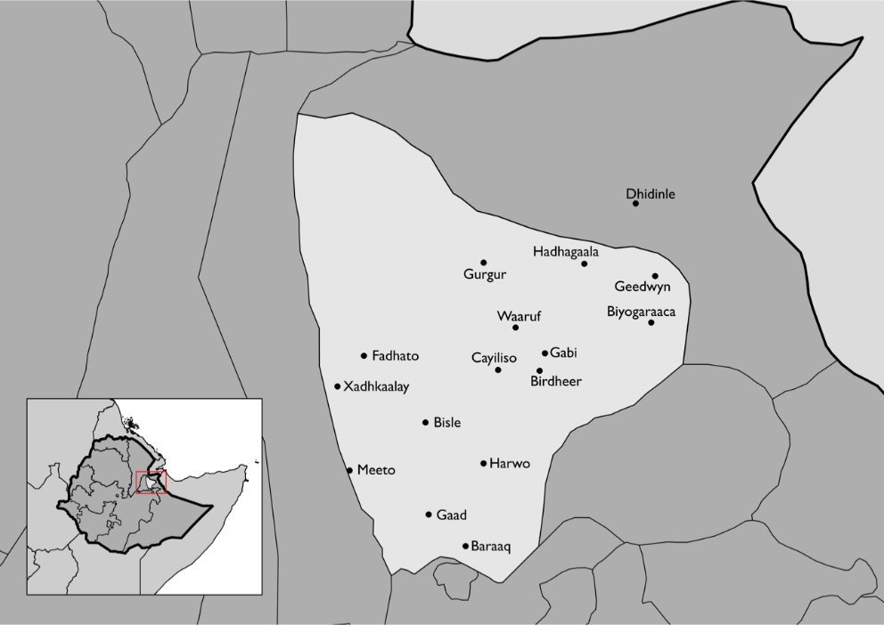

West Hararghe Zone
West Hararghe combines extremes of terrain, climate and livelihoods, ranging from high-altitude to semi-arid middle-highland rain-fed agriculture and arid lowland agro-pastoralism. Bordering Somali and Afar States and East Hararghe and Arsi zones, West Hararghe has few major towns, the nearest large economic centre being Dire Dawa at some 200km distance from the main Zonal town, Chiro. It has a limited, if growing, feeder road infrastructure. While the new Ethio-Djibouti high speed rail link passes through Me’isso district, it is not regarded as of long-term economic benefit by the local population.

While settled agriculture produces staples and vegetables for household consumption and market sale, a large part of the rural population depends upon the cultivation of the drug khat as its main cash crop. West Hararghe suffers from endemic chronic and acute malnutrition in the under-5 population. As in Sitti zone, services are limited, and access to water in the more remote rural areas poor and drought-prone. Food aid is frequently distributed to much of the population beyond those receiving social protection support from PSNP. However, development or resilience-building investments have been very limited here, too. NGO presence is sparse, except in times of severe need (notably 2002, 2008, 2011 and 2015-16) when short-term nutrition programming has been the main focus of response.

Figure 2: Study villages in West Hararghe Zone
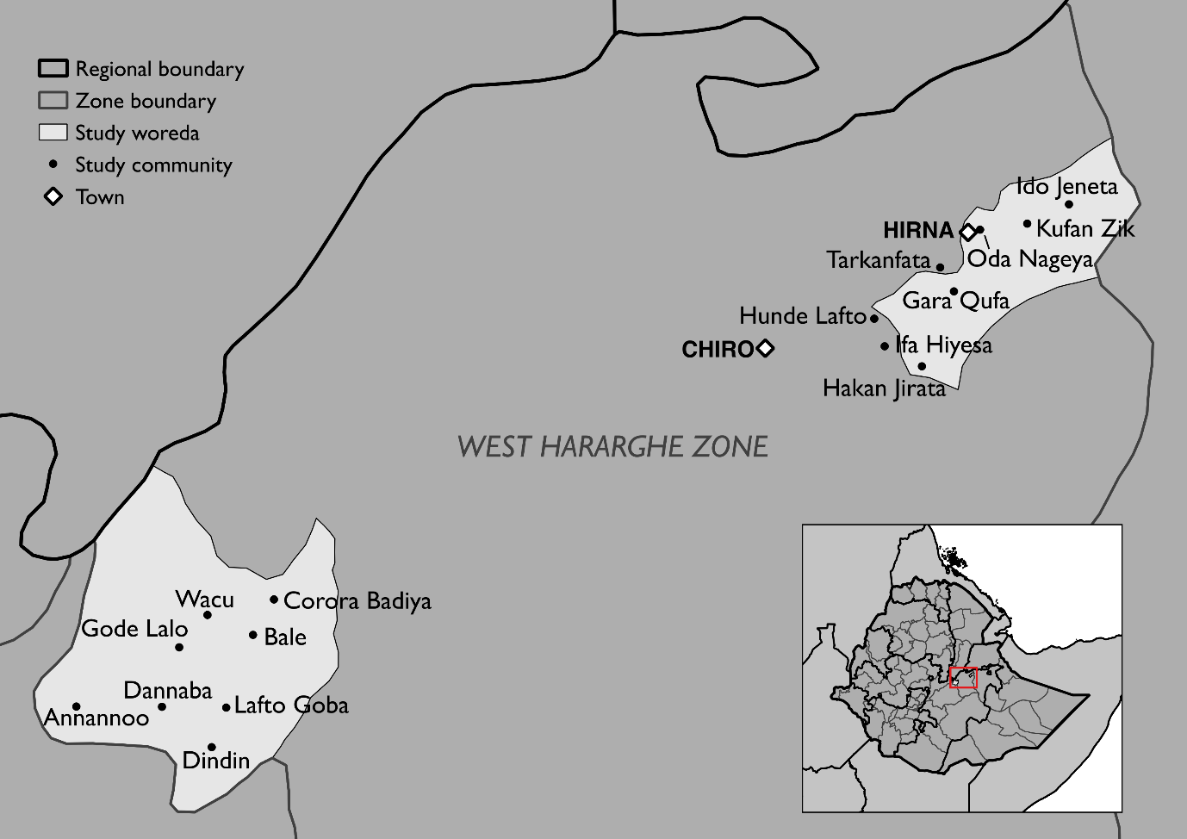

- Methodology
This report is based on two main sources of information. VE has been conducting a thematic evaluation of MYHF since 2014, including in Sitti and West Hararghe Zones, conducting regular face to face individual interviews with a panel of informants to follow the changing fortunes of around eighty households in each zone. This has given very rich information in real time about how the crisis developed and how people responded. That understanding has been combined with a supplementary study, focused specifically on the three research questions above. This separate study used a mixed methods approach, combining quantitative and qualitative techniques. A rapid initial stage of three focus group discussions in each Zone was used to inform the detailed design of the further qualitative interviewing and in designing the survey instrument.

The intention was to conduct comparative research, in villages which had received early aid (which had been considered as September 2015) and in other villages which had received aid later, in April 2016, as a control. This clear distinction did not prove possible, partly because not enough information was available about actual delivery dates in different villages. It had also been intended to use the survey to compare kebeles which had received developmental investments of one of three types (asset creation, income generation and water infrastructure) with control kebeles which had received no such investment. This plan had to be abandoned because after several months of enquiry from Government offices, operational agencies and their donors, it was still impossible to find out which kinds of interventions had been implemented where. As a result, the survey did not include questions about resilience building investments, and a sampling methodology that targeted investment recipients could not be used. The FGD facilitators simply had to be prepared to investigate whatever investments they discovered, if any.

Based on the information available, four kebeles were selected in Shinile and Hadigala districts in Sitti Zone, and in Tulo and Anchar districts in West Hararghe Zone, ensuring a wide coverage of the survey including the more remote and less accessible parts of the Districts (see figs 1 and 2 above). The Districts in West Hararghe were from the middle- and higher altitude parts of the Zone, since arid, lowland areas were being studied in Sitti. Kebeles consist of several villages; for this study, one village was selected from each kebele. Two focus group discussions were held in each selected village, and a survey conducted with between 28 and 35 respondents, for a total of 480 completed interviews in each Zone. Because of a lack of reliable and comprehensive sampling frames, respondents were selected by random walks. GPS coordinates were taken on the tablets used to administer the survey, allowing for some oversight of the spread of interviewees. Any available adult in a selected household was interviewed.

Of the two FGDs in each village, one took a quasi-goal free approach to look at coping during the crisis (i.e. did not raise any specific interventions with participants), by developing a crisis calendar with the participants. The second FGD examined specific interventions (including relief aid) using theory-based enquiry (i.e. developed in advance a causal model by which the intervention worked and investigated in detail each link in the causal chain from intervention to impact), also using a crisis calendar. The FGD were also used to quantify as much as was possible, to complement the statistical treatment of data generated by the survey.

Field work was carried out in two phases. An initial rapid scoping exercise was conducted in November in Sitti and in December in West Hararghe. Subsequently, the in depth research and survey were carried out in December 2016 in Sitti, and at the end of January to early February in West Hararghe.

This primary research was supplemented with key informant interviews, at zonal, state and federal level, and with a study of documentation including project documents and other research studies.
The survey assessed various parameters which had previously been identified, either from the scoping study or from other documentation, as being symptoms of or indicators of stress. These included the reduction of meals for adults and children, the sale of assets, the sale of breeding animals in particular, livestock mortality, removing children from schooling, indebtedness, forced migration and engaging in various coping strategies such as engaging in different income generating activities or looking for wild foods. The survey also contained subjective self-assessments by respondents about how well they coped, compared both to their own expectations and to other people in the communities. It had been hoped to use these various parameters create an overall measure of how well people had coped or how much they had lost in the crisis. It would then be possible to see how much more or how much less people had lost when they received different kinds of aid at different times, and to relate the coping ability to various other factors, such as the dependency ratio in the household, how much land they owned, et cetera. The data from the two zones could then be combined to see if there were any more general findings. It was intended to use the qualitative research to substantiate the findings, both through simple triangulation and also, especially by using the theory based approach, to investigate the mechanisms by which aid had brought about different outcomes.

It proved impossible to construct such an overall measure of coping or loss, because there were no significant correlations between the different symptoms of coping with stress. Different households used different strategies and suffered from losses in different ways. This is a fundamental challenge to assessment methodologies which are based on the reasonable assumption, one also used in planning this study, that one form of suffering or loss can be taken as an indicator of stress generally. One would expect, for example, the prevalence of households which had sold large numbers of livestock or accumulated larger amounts of debt to be a general indicator of stress (due either to greater drought intensity or higher vulnerability) and it would also be expected that these symptoms would then tend to be correlated with other signs of coping or stress (e.g. reducing meals, selling other assets, migrating). However, the findings showed that households which suffered in one way were no more likely to exhibit any other symptom of stress than other households. As a result, it would be meaningless to combine the various parameters into a single score. Instead, the different parameters are analysed independently in a detailed accounting of the different losses sustained by household during the drought (section 4), and data from West Hararghe and Sitti have had to be analysed separately.

- Overview of the crisis
It would be misleading to understand the drought in either Sitti or West Hararghe as a natural disaster caused by a sharp climate shock due to El Niño. The drought which is thought of in Ethiopia as the El Niño drought, ran from 2015-2016. In Sitti, rains failed from 2014, and the drought was already severe before El Niño had even begun. Both Zones are supposed to enjoy two rainy seasons a year, shorter rains in March-April and longer rains between July and September/October. Sitti enjoyed good long rains in 2013, but this was itself seen as a respite year following the generally poor rains since 2011. In some parts of Sitti the short rains in early 2014 were very poor, and the long 2014 rains failed completely. Around half of the population was thus already in crisis by the end of 2014, particularly in the south and east of the study area.

The crisis developed at different times in different part of the Zone, largely due to differences in the weather experienced, but modified by other local differences such as availability of ground water and alternative opportunities in the local economy (which may explain why many of the kebeles closer to the main road began to suffer later). The differences just within the Zone are striking. Already in mid-2014, livestock were starting to die in parts of Hadigala, when much of the area was not yet suffering great stress. Lack of drinking water in some villages in the West of Shinile district was already forcing people to move either into the centre of the kebeles or into neighbouring kebeles to seek assistance in the dry season even before the first widespread rain failure in July 2015.

Herders returned home with their animals after the normal seasonal migration in the June-July dry (Hagaa) season 2014, in the expectation that rains would refresh the pasture in August. When it became clear that these rains were failing, culling of calves already began in some places, e.g. Fedhato, in order to reduce the burden on their lactating mothers and help keep them alive. Animal mortality already began to rise.
The crisis was still relatively localised, and even most of Somali region remained largely unaffected. However, the degree of suffering was well known locally. A huge aid effort was mounted by the (Issa) clan kinsmen of the people of Sitti, in particular by the business community and civil servants, centred around Dire Dawa. Food aid was distributed on a massive scale considering the resources available to those private citizens, with two or three months of food given to many people in different kebeles across the zone in late 2014/early 2015, well before the Government and international relief aid effort was fully scaled up. The regional state asked for extra assistance for the zone with the failure of the long rains in September 2015, though this was several months after reported cases of children dying from drought related conditions in Shinile district (with the failed short rains in April 2015). Some relief aid was delivered, particularly for water, to treat severe acute malnutrition and, in one or two areas, cholera.

The drought caused many herders to take their livestock further afield than normal migration patterns. Ethnic conflict prevented many from travelling into Oromia, but reports were received of pasture in Somaliland. Some moved there in late 2014, and these numbers grew when the following short rains failed in April 2015, because everyone had received the same information. The huge population of people and their animals which arrived soon resulted in the pasture being finished; and with so many animals congregated together, diseases ran through the animals, already weak from the journey of almost two weeks. Food aid was provided by the people of Somaliland which prevented human mortality, but by the middle of 2015, many had lost almost their entire herds. And all this, it should be remembered, happened before the El Niño drought had even begun. The crisis had taken people by surprise. The most severe droughts are known by local names: this one is called the sudden, or unexpected, drought.

In West Hararghe, the onset of the drought was seen as a continuation, and intensification, of an existing trend of several years of poor and unpredictable rains. In September 2014, one informant was already saying:

“Over recent years, we have lost two months from each rainy season. Now the rain is not coming at the right time: it starts late and finishes early. We prepared the land for planting at the start of the short rains [March 2014], but then they stopped, so we had wasted our time….. I don’t know what tomorrow will bring, but all I do know is that the rains are changing, they are less and they fall at the wrong time”
(VE interview, Sept. 2014)
T
he story of crisis from West Hararghe is less clear-cut, because although their situation became extremely serious, it is perhaps better understood as a deepening of a chronic crisis, rather than as a one year natural disaster. There had been poor rains for several years before El Niño, and in Tulo, the short rains failed in 2014, but there was at least some rain in the long rainy season (July-Aug 2014). The same pattern of poor and irregular rains continued in 2015 and 2016. Although many people spoke of the rainy seasons failing completely, most people managed to get some harvest. Many people owned a few livestock which they were largely able to keep alive by feeding them straw from their fields, even when the grain harvests failed.
West Hararghe is relatively remote economically and there were few alternatives income sources for people to draw on to cope with the loss of their harvests. Some looked for daily labour, though this was hard to find; a few tried to engage in some petty trade; and some left to find work in Addammaa, Awash, Matahara or Malagaa, though this was relatively rare. The most striking thing about the crisis is how little happened that was unusual. There was some human mortality because of the drought, though this was limited, and aid clearly played a key role in the numbers being as low as they were.

There is, though, no grand explanation of how people did survive. Most did not do very much that was different to any other year; aid supplemented the little that people had to keep them going. This too is hardly out of the ordinary. West Hararghe receives food aid frequently in addition to PSNP, and both are widely shared. The timing of aid can be somewhat erratic, and there are several reports of food aid being delayed even from one year to another. This, ironically, sometimes meant that food aid arrived when needed, even though it had been planned to be delivered before there was any thought of a crisis. Beyond productive safety nets (PSNP) and joint emergency operations programme (JEOP) food aid, assistance is very limited in West Hararghe, in particular outside the project areas of the only two international NGOs with any consistent presence.

Assistance
This study is not an evaluation of the aid response to the 2014-16 drought. It is specifically a study examining the contribution of early response and resilience investments to coping. This report therefore does not attempt to give a detailed picture of the entire aid effort, nor does it attempt to evaluate the overall impact of the aid. It must nevertheless be acknowledged that the national effort, by the Government of Ethiopia and its international partners, was enormous. The Government’s own contribution to the aid effort was noted by many in the aid community as being exceptional. Nationally, the scale of the challenge was huge, and Sitti and West Hararghe were just two small areas that needed assistance. Mortality from the crisis was low, and the aid effort undoubtedly was an important contributing factor in avoiding mass mortality. That effort, particularly involving food aid, therapeutic feeding, health interventions (around measles and cholera) and WASH, is not the subject of this study, though, and it will undoubtedly be evaluated by others. This report looks at the degree to which it was possible to avoid a dire emergency by the use of aid given before human suffering reached crisis proportions.

There is no clear record in any one place of all the different forms of aid that were flowing in to either Sitti or West Hararghe. This corresponds well with the somewhat erratic and ad hoc nature of how aid as a whole was managed – each agency manages its own aid stream in its own way. In Sitti zone, assistance was largely slow to arrive, with the main bulk being delivered after July 2015 (i.e. following the publication of the revised HRD), with some backlogs enduring until late 2016. Regular PSNP programming was not linked to a drought appeal and so arrived every year, but distributions in 2016 were delayed by backlogs in procurement during 2015.

Figures 3 and 4 show how many people reported receiving aid (specifically from Government or international agencies) in each period, together with the number of people who reported that they were in crisis in Sitti and West Hararghe respectively.
Figure 3: Calendar of % of people in Sitti receiving aid versus % of people reporting they are in crisis
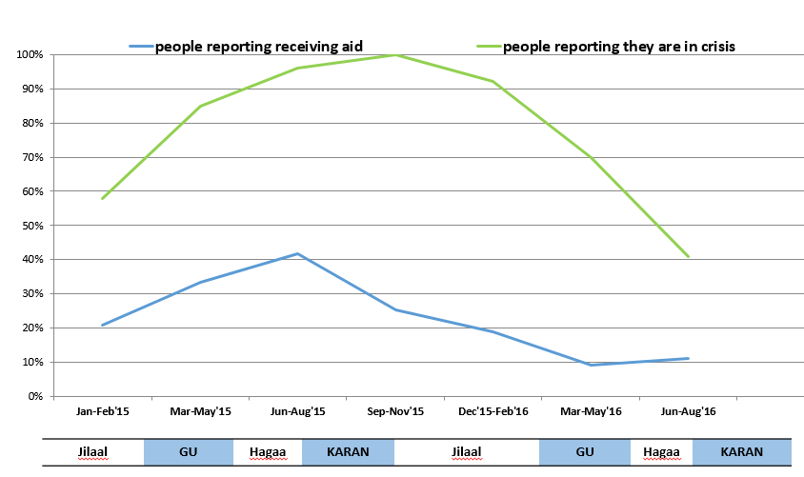
Figure 4: Calendar of % of people in West Hararghe receiving aid versus % of people reporting they are in crisis
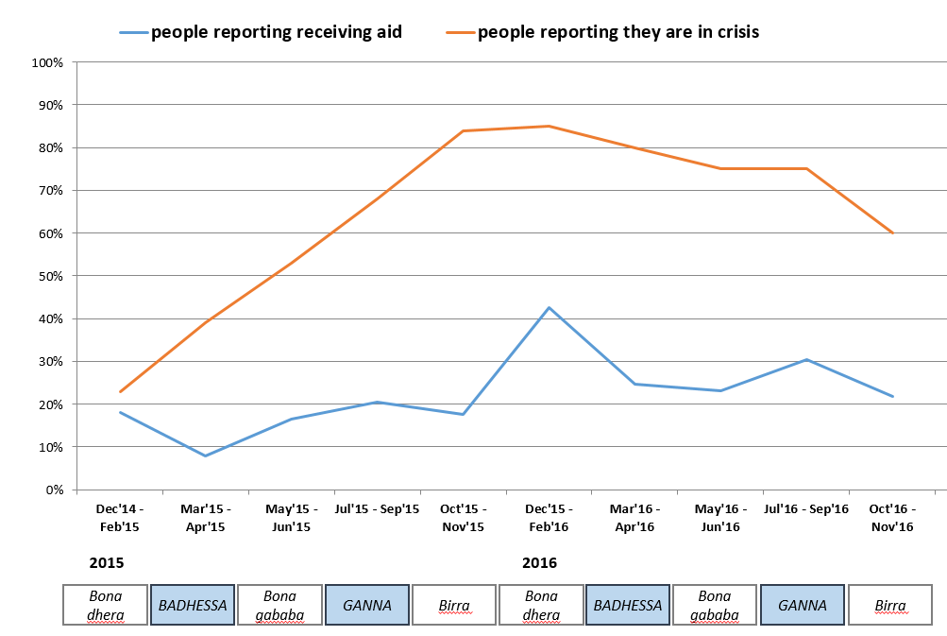
Three things are striking. Firstly, in each zone, over two thirds of the population say they had been in crisis before any emergency appeal had even begun. In both Zones, aid was only properly onstream at least six months after the crisis was already fully developed (and in parts of Sitti, only a year later). Secondly, the numbers of people who reported receiving aid was always very much lower than the number who said they were in crisis, and in neither Zone did the numbers ever reach 50% of households. This was surprising. Thirdly, the flow of aid from emergency aid operation reduced more quickly after rains returned in March/April 2016 compared to the rate at which people felt crises ended. In Sitti and West Hararghe, seven and twelve months respectively after the peak of people saying they were in crisis had passed, over half of households were still reporting being in crisis. (In areas were the household depends heavily on livestock, it is actually surprising that people report that the crisis was over within a timescale of months following a return of rains, when it is clear that their milk production would not even be back to normal, let alone herds being rebuilt. People used their own perception or definition of crisis, which presumably included some psychological element: once hope was restored that they could start to recover, did they already define the crisis as over?).
The last 10-15 years have seen a significant increase in the attention given to livelihood protection in the humanitarian sector. This long shift in thinking has been driven especially by experience in agro-pastoral and pastoral areas, where a drought not only causes a short term loss of income (e.g. a failed harvest, loss of milk production) but also enormous loss of productive wealth, with the potential for loss of over half of all livestock in a serious drought. In Sitti, a number of agencies in 2015/16 used such approaches, with interventions like targeted distributions of fodder, vouchers for purchasing veterinary care and support to livestock marketing. However, these were fragmentary and, in general, late (see figure 5), occurring only after peak animal mortality was already over.

Figure 5: Calendar of livestock mortality and livestock interventions in Sitti Zone
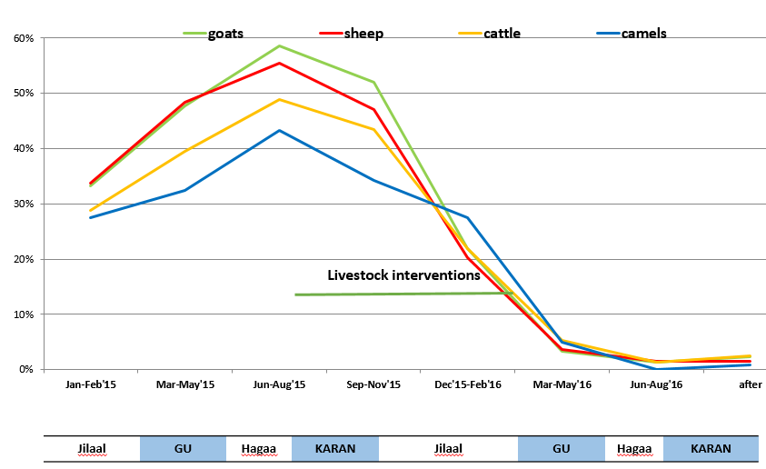
Another innovation from the past decade is the establishment of mechanism in longer term programmes to enable some funds to be diverted towards a response if a crisis should develop or threaten during the period of implementation. These are often called ‘crisis modifiers’, after USAID’s terminology, but they were also used by EU and DFID during 2015. Their use is discussed in detail below (see 8.1); overall, they were not triggered very early, they were often subject to procedural delays at the height of the crisis and were able to generate only very limited funds in relation to the scale of need.

In both Sitti and West Hararghe Zones a recurrent theme throughout the period October 2014-December 2016, identified in interviewing by VE both for the thematic evaluation and this study, was the major deficit in potable and irrigation water source development, and the paucity of long-term (resilience) investments in general. Government spending is limited in both Sitti and West Hararghe. Other medium-term development investments in Sitti were limited largely to the USAID PRIME and DFID Pastoral Development Programmes and, more recently, the EU/ECHO RESET initiative, and the PSNP social protection programme. In West Hararghe a similar situation pertains, with CARE International and World Vision International being the only international agencies engaged in medium-term programmes in certain districts.

- The lasting impact of the crisis
This next section quantifies, as far as is possible, the various longer term impacts of the crisis, by examining the economic loss of productive assets and the costs related to the debt burden, lost education and any negative impacts from migration. Most of the quantitative evidence comes from the survey, which included detailed questions to examine each of these different parameters of loss.

Livelihood profiles have been established for all the research areas by the Government of Ethiopia using the Household Economy Approach (HEA). These HEA baselines are based on a population breakdown into different economic groups or ‘wealth groups’ as identified by the communities concerned. These wealth groups are usually defined on the basis of asset ownership. The survey data permitted the classification of each respondent household into one of the wealth groups for their livelihood zone. Three wealth groups were used in West Hararghe (‘poor’, ‘middle’ and ‘better off’) and four in Sitti (‘very poor’, ‘poor’, ‘middle’ and ‘better off’). It must be stressed that any use of the terms very poor, poor, middle or better off in the rest of this report relates specifically to the wealth groups as described in the 2007 livelihood profiles and applied as described in annex 4. There is no implication of any independent judgement on the nature of relative poverty or wealth.

Field research for this study was undertaken after the drought was over, but not necessarily after the crisis. Some people were starting to recover, but it was too early to start assessing how recovery would progress for different people, or what the impact of the then-looming next crisis would be. The study looked at different parameters to analyse the damage caused to people by the crisis, and how it might impact households in the short and medium term. These parameters were: assets lost; levels of debt incurred; non-economic costs (education and migration); and people’s own subjective assessment of the recovery period. It was beyond the scope of this study to assess, or even document, the personal suffering endured (e.g. suffering from hunger and despair, seeing relatives sick or dying), though psychological effects of the crisis may well have a longer term impact on economic recovery, as they affect future motivation, investments and other decision making.

Lost assets
There were only two main assets in West Hararghe and Sitti, livestock and land. In West Hararghe, most people had a little of both, in Sitti some households had arable land, but most relied only on livestock.

Sitti zone

It is very hard to be sure of the size of livestock losses because there is no independent way of verifying people’s claims about their own losses, which they may have reason to exaggerate. Qualitative interviewing and survey responses certainly substantiated each other regarding the broad picture of livestock losses, and these can be taken as fairly reliable, since the reports include detailed anecdotes about how people tried to protect their herds at different times, where they moved and where and when animals died. However, qualitative fieldwork could not give an accurate or precise estimate of the size of losses for different people, and yet surveys do not give reliable information. The figures below do not claim to be exact, but the study team is confident that they present a reasonably reliable picture of what has happened.
According to survey response, the average (mean) loss of livestock during the drought was 77%. This is calculated by dividing the aggregated reported herd at the time of the survey (in TLU) by the reported pre-crisis herd (in TLU). The median loss is slightly higher, with just 45% saying their current herd was 20% or more of the size of the pre-crisis herd. Reported herd loss was much lower for those who had smaller herds. Survey results show that the ‘very poor’ reported losing just over 60% of their herds (in TLU), ‘middle’ households reported losing over 80% and the ‘better off’ reported losing 85% of their total herd. This is well corroborated by FGD reports. Those who had fewer animals were able to protect some of them using food aid, bought food, and collecting a variety of vegetation, including even prosopis. Larger herds were forced to migrate, and it is probably fair to trust the numerous stories of people returning from Somaliland with no animals at all, or with only a handful of animals left alive. This finding is interesting because it runs counter to conventional thinking that smaller herds are less mobile and typically suffer the highest losses, whilst the better-off with larger herds are better able to keep their animals alive.

Even when food prices do not increase greatly, as, perhaps unusually, they did not in the 2014-16 drought (see fig. 6), the terms of trade between food and livestock typically become much worse for livestock keepers during a drought, because of the crash in animal prices. A large increase in animal sales to buy food is therefore expected to play a role in herd depletion. This study did not find that this was the case. Pastoralists sell animals in normal years in order to finance their lives. Overall, sales were no higher during the drought for all except the better-off, for whom there was perhaps a small increase, even though livestock typically lost around 60-70% of their market value. This is largely because the market for animals completely collapsed by the start of 2015, when animals were already in weak condition, and were often not physically able to walk the long distances to market. Almost all herd depletion thus occurred because of mortality, combined with the loss of normal reproduction to replace normal levels of sale.

Figure 6: Maize Prices in Selected East African Markets, 2014-16
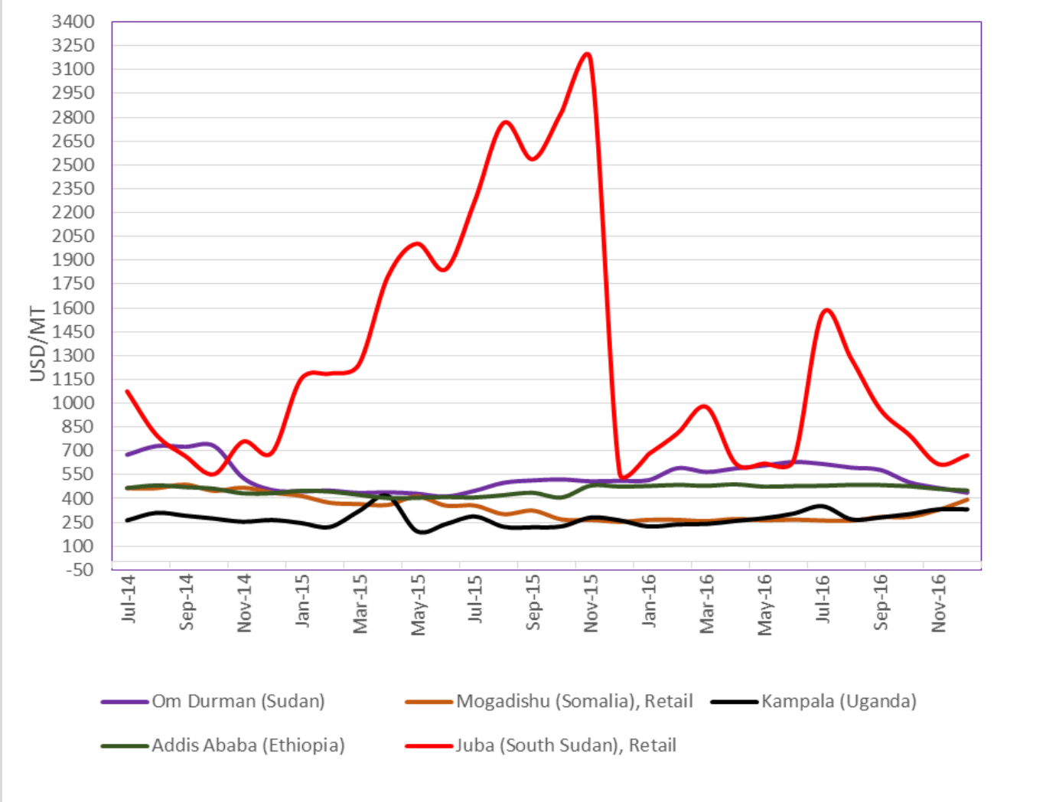
Note that only in Juba, where civil war was driving prices higher, did maize prices show usual movement during 2014-16. The prices for sorghum show a similar pattern. Source: FSNWG January 2017.

All estimates below use deliberately conservative figures of herd loss. Even allowing for exaggeration, it is reasonable from all the evidence available to accept that herd losses for this group were at least 60%, and only 6% of better-off and middle households reported having losses this low. No implication is intended that herd losses were only 60%: figures as high as 80% would be extremely rare in droughts, but all accounts confirm that 2014-16 was the worst drought to hit Sitti in several decades, and so even such figures may be credible in some places. Only 11% of the very poor and 8% of the ‘poor’ reported still owning herds with less than 40% loss from pre-crisis levels, and again, this figure will be used below for these two groups, again with no implication that losses could not have been considerably higher. However, by using conservative figures it will be possible to illustrate a level of losses that all readers should find credible as a best-case scenario. It is stressed that the following calculations are intended to be indicative only, to give an informative picture of the rough scale of reported losses.

Although people in general often wish to underreport their wealth to strangers, for obvious reasons, it is possible that the tendency to wish to stress personal losses may mean that reports about pre-crisis herd sizes are more reliable than may often be the case. In fact, these numbers corresponded well with the HEA profiles, which were established through extensive interviewing, and using triangulation from internal consistency. At pre-crisis prices, the value of herds of the population could be estimated as follows: the very poor (15-20% of the population) owned around $800 worth of animals; the poor (30-40%) owned around $2,500; the middle (20-25%) owned around $5,500; and the better off owned around $14,000. An approximation of minimum financial losses to each group are given in table 1.

Table 1: Minimum financial losses to each wealth group
 | % of sample | Pre-crisis value of herd (US$) | % loss  (reported) | % losses  (best case scenario) | Financial loss per hh  (assuming best case)
Very poor | 18% | 800 | 64% | 40% | $320
Poor | 36% | 2,500 | 74% | 40% | $1,000
Middle | 23% | 5,500 | 82% | 60% | $3,300
Better off | 23% | 14,000 | 85% | 60% | $8,400

Definitions of wealth groups taken from Livelihood Profile 2007. Actual herd size averages taken from Valid Evaluation 2017 survey data. All herds converted to TLU, and valued at 4,000 ETB per cattle equivalent (0.7 TLU). $1 = 22 ETB.

In order to estimate the total asset loss in the zone, it is necessary to use a weighted average of livestock mortality, considering the size of herd for each group and the relative size of each wealth group in the population. Although the study sample was not designed to be representative of the non-urban parts of the zone as a whole, there is no reason to believe that it is particularly skewed or biased, and it is probably good enough to give a useful estimation, especially in the absence of other data or calculations. The 2014 population of the zone is estimated at 550,000, or around 75,000 households, of which 14% were classified as urban. The conservative estimates of herd reduction above (‘best case scenario’) give a weighted average of 56%, or a value of around $4,200 per household. If the sample is indeed reasonably representative of the non-urban population of the zone, it suggests that the overall value of loss of livestock for Sitti Zone alone was over $275m. This would imply that the financial loss for Sitti Zone alone was equal to the entire state budget of Somali Region for 2013, or the entire State budget for Sitti for ten years (assuming that total public expenditure in Somali Region is distributed equally per capita across the State).

West Haraghe

Because land as a productive asset is not so easily lost in drought, levels of asset loss were much lower in West Hararghe than Sitti. Despite several reports in village FGDs that out of hunger, people had resorted effectively to mortgaging their land (i.e. accepting payment up front for several years’ rental on their fields), this was not confirmed by survey respondents, with just 7 respondents reporting having rented out land as a crisis measure for more than one year, and only three of these renting land out for three years. It is likely the prevalence of multiyear rental is more reliably given by individual responses; it seems reasonable to conclude that the FGDs have truthfully reported what indeed occurred, but that they have idealised this into a general response by ‘people’, rather than recognising that these were exceptional cases. Exactly the same pattern was seen for other distress sales, with FGD reports that people “survived by selling assets” (ie other than livestock), but only 2% of survey respondents reported having sold any possessions (apart from livestock). Although it is worrying that even two people reported having to sell their houses in order to eat, any calculation of lost assets across the population as a whole can disregard losses from either land mortgages or the distress sale of other possessions.

Livestock losses were smaller in West Hararghe. Livestock holdings are more geared towards regular sales, which as a proportion of the herd are about twice the size of sales in Sitti Zone for each wealth group. (The poor sell about twice as much as the better-off in % terms in both Zones). During the crisis, sales increased considerably, especially for the better of. The poor increased sales by around 50%, but the middle more than double sales and the better-off sold four times as many animals (in TLU) as normal. This was the primary driver of herd depletion. Mortality was relatively low: fewer than 50% of livestock owners lost either a cow or a goat. This is understandable, as it was seen in Sitti that those with fewer animals were able to protect them better, and in West Hararghe the rains did not fail as completely as in Sitti and the drought did not last as long. If total asset reduction is considered as excess sales (i.e. sales during the crisis less normal sales for that period) plus mortality, then total animal losses were on average 0.4 TLU for the poor, 1.2 TLU for the middle and 3 TLU for the better off. For the different wealth groups these can be respectively valued roughly at around $110, $350 and $850 per household. It is obvious that the financial loss to West Hararghe was only a fraction of that sustained in Sitti – but it must also be remembered that the financial capital available to households in West Hararghe is also only a fraction of the asset wealth previously held in Sitti. (This is in part because the productive capital of farmers in West Hararghe is land, which is not easily commoditised in Ethiopia.)

These calculations of financial asset loss do not represent the full economic cost of the crisis for households. No account has been taken of lost income. For West Hararghe, this is largely due to the poor or lost harvests, and some loss of income from agricultural employment. For most people, these harvest recover immediately, as few people reported being unable to plough their land because of distress sales of ploughs or oxen. Loss of income from future livestock sales has not been calculated. In Sitti, where income from livestock is more critical, average lost household income, from herd multiplication and milk production has conservatively been calculated at just over $1200 p.a., or $90. This loss will progressively decline over the coming years, assuming favourable conditions.

Debt
Debt is often expected to be one of the lasting impacts of crises. This study raised some question of how far debt should be seen (only) as a negative cost of crisis, and how far the ability to borrow money for multi-annual consumption smoothing should be appreciated as an important part of coping.

An understanding of crisis indebtedness must start from an understanding of borrowing patterns outside of crisis. Borrowing is a fairly common part of household economic activity in both Zones, though in Sitti it is both more prevalent (30% of household borrow normally compared to 20% in West Hararghe) and at greater levels: normal pre-crisis debt levels of households which borrow were mean/median of $135/$90 in Sitti compared to $90/$45 in West Hararghe. Borrowing cannot be seen simply as a result of poverty stress, because both rates of borrowing and levels of debt are broadly similar across wealth groups. The way in which debt is integrated into economic life is also seen in where money is borrowed. In Sitti, most borrowing is in the form of buying on credit from traders, with just 1/3 from family and clan, and much less again from any form of MFI. Interviewees talked of reluctance to engage with MFIs, because their terms are not seen as favourable (including cost of borrowing, the repayment period and the need to begin repaying immediately, or in other conditions). In West Hararghe, over half of borrowing is from friends and family, and borrowing from VSLA is also as common (except for ‘better-off’ households), following a number of initiatives by NGOs over recent years to create various associations.

The drought increased borrowing to some extent – though only around half of households in both Zones reported having higher levels of debt than normal at the time of the survey (December 2016). Additional debt was relatively modest for most people, though, particularly in West Hararghe. There, additional borrowing was an average of $45 per household (an increase of 50% over normal borrowing), and most people (87%) said they would be able to repay the loan in less than one year. In Siti, debt was a little higher, at around twice normal borrowing rates (an additional $85 per household on average). These levels of debt are considerably less than those reported in Oromia by AKLDP 2016, where additional borrowing because of the drought was an average of $150 per household, although they are in line with the proportional increase in normal levels of borrowing reported by AKLDP (of 65%).

In West Hararghe was that more people owed money to family and friends, and fewer had borrowed from VSLA. The terms and conditions of VSLA, including the need to start repayment immediately and to pay interest, do not favour it as a recourse for emergency consumption, only for investment. Again, crisis borrowing cannot be interpreted simply as a failure to meet needs, because in both zones borrowing rates and amounts were similar for all wealth groups, with slightly higher levels of debt for the “better off”. Across all wealth groups, the vast majority of those in debt did not feel they would have a problem to repay, with 87% in West Hararghe saying they would repay the amount within one year, and 75% in Sitti saying they would repay within two years.

There is one other reason to be cautious about using debt as an indicator of suffering from the drought. As discussed the parameters considered in the survey as indicators of suffering or difficulty in coping included levels of indebtedness, skipping meals, loss of assets, distress sales, taking children out of school and a subjective assessment of how well they had coped. The lack of consistent correlations between these parameters was striking, meaning that people who did more of one were not necessarily more likely to do any others.

TwoStep Cluster Analysis was undertaken to see how the various factors could be interpreted together. This procedure helps to reveal sub-groups, by dividing the sample into ‘clusters’ which are internally as homogeneous as possible but externally as different as possible from each other on the chosen parameters. According to this procedure we have identified three clusters of households (see annex 2). One cluster (about ¼ of the respondents) was least likely to have cut back on meals, to have migrated, to have sold female animals, and the most likely to say they coped fairly well. This group also had low levels of debt. They could be said to be the cluster that had coped best. However, the rest of the population was split equally between a group who borrowed and another who did not. In Sitti, both other clusters had to cut back on meals, but the group which borrowed thought they had coped about the same as others, whereas the cluster which borrow less was most likely to believe it had coped very badly and worse than others. In West Hararghe, the picture is even less obvious, because the cluster which borrowed believed it had coped the best of all. The ability to borrow is as an important part of coping for many. This kind of analysis cannot be over-interpreted, but in refusing to allow a simple story to be told, it corresponds well with the way in which debt was unrelated to wealth groups. It would be wrong to argue that borrowing is simply a positive opportunity, a coping strategy that prevents the need for negative, distress strategies; however, it is far from clear that a simple story of ‘debt as bad’ can be told, either.

Other

Education.

Children drop out from school during crises for a variety of reasons: schools close, children have to go to work to find food, children become sick or malnourished, lack of school fees/compulsory school material, or they are forced to migrate. The 2016 HRD showed that the risk to children’s education from the crisis was very much on the humanitarian agenda, giving an estimate of 1,287,444 school-aged children and adolescents are already “unable to access quality education opportunities as a result of drought”. The pastoral areas were particularly highlighted.

“Schools in drought-affected regions have closed due to pastoralists moving with their children in search of water and pasture. Moreover, in almost all affected schools, high absenteeism has been observed as children walk long distances to assist parents in fetching water; inadequate feeding limit the capacity of children to stay in class.”
2016 Ethiopia HRD.

If the children cannot get back into school after an absence for whatever reason, it can be potentially one of the longer term damages to people’s lives from crises.

The evidence from both Sitti and West Hararghe is that additional school absenteeism or drop-out was relatively low during the drought, probably in part due to school feeding interventions. School drop-out had slightly different patterns in Sitti and West Hararghe. Fewer dropped out in Sitti, and drop-out was mainly because some schools in outlying areas closed when teachers deserted schools, rather than because of the kinds of household level problems reported above. Dropout was plausibly related to the household level impacts of the crisis in 4% of households (i.e. sickness/malnutrition, lack of money, need to go to work), though this probably overestimates the impact of the crisis, since there is presumably some absenteeism from sickness etc. in normal years. (No baseline data existed so this was ignored giving a maximum estimate of the drought impact.)

The link between drop-out and economic stress is clouded by the fact that drop-out rates were highest for households in the better-off wealth group, and the reasons given were not about needing to herd animals – in fact, all the cases of sickness or malnutrition in the sample were from better-off households. Most children are now back in school, with less than 3% of households reporting that not all their children were back. (Again, this will overestimate the impact of the drought because some or all of these may have left school before September 2016 anyway.) We heard no reports of children who temporarily dropped out having to repeat a year.

No schools closed in the study kebeles in West Hararghe but drop-out was much higher at 14% of households, all for reasons which are plausibly drought-related; about half of this was for sickness or malnutrition and drop-out was twice as common among ‘poor’ households and in villages further from the centre of the kebele. (The caveat that the figures might overestimate the drought impact because of the lack of baseline data of ‘normal’ sickness and absenteeism, see above, applies here too.) The pattern of return is also more worrying in West Hararghe than in Sitti. A third of drop-outs had not returned to school (i.e. in 5% of households), and of those who returned, most had to repeat a year. The pathway through school was thus disrupted in the long term for a child in 12% of households.

Across the two zones, these figures may be considered as relatively moderate, especially because of the normal rates of enrolment in school. Other causes for drop-out from education even in primary school have much more impact than the drought, and secondary education attendance is low in Sitti and West Hararghe. Although the VE data cannot be directly compared with the HRD 2016 estimate, the figure of 1.29m is around 10% of the national primary school population, suggesting that West Hararghe may be roughly in line with the national picture as estimated by HRD 2016, and that Sitti may have been impacted less – though this could be attributable both to interventions to keep children in school, and the normally low rates of schooling.

This assessment relates to the immediate impact on school attendance: it is not an estimate of the loss to an individual (or to a household) caused by a child missing school. It is clearly impossible in a study such as this to assess the impact of loss of schooling on those lives of those children as they grow up, or on their families. Such a study would have to examine the quality of education in Sitti and in West Hararghe, and the benefits that are derived from more years’ schooling in an area where so few children progress to higher education or who further a professional career through education.

Migration.

Migration is common in Somali Regional State, and goes beyond movement with livestock by pastoralists. One in five households already had one or more members living away from home before the crisis. There was a huge increase during the crisis, with over a third of households experiencing extra migration, mainly to Djibouti and Dire Dawa, either to look for work or to stay with relatives (or both). Most of these had not returned at the time of fieldwork, so that in this period alone unreturned migration was 150% of the level that existed before the drought.

The impression given by qualitative interviewing was that migration was also a common coping strategy in West Hararghe, but this impression was to some extent contradicted by the survey data, which showed much lower levels of migration than would naturally be inferred from the descriptions in FGDs. The study zones in West Hararghe are much less integrated into a migration economy, with previous levels less than half that of Sitti (9% of households), migration rates during the drought much lower (only 6% of households), and fewer people per household moving (mainly only one person). Migration was almost entirely domestic, with just one person from the sample of 480 households moving to Dubai, and three-quarters had already returned. The FGDs recounted some stories of migration to the Gulf through human trafficking. One village spoke of twenty young men and ‘many females’ using these routes, and costs were very high, with families having to sell all their livestock and even houses to pay.

It is beyond the scope of this study to say how far migration should be seen as economic integration, representing livelihood opportunities which are badly lacking in West Hararghe; or whether it should rather be considered a distress (“negative coping”) strategy, and counted as a cost of the crisis, which to some extent accords with the FGD in West Hararghe, where people spoke of the arrival of aid having prevented further migration.

- Early aid and avoided losses?
There were several difficulties in tracing any impact of early aid on avoiding losses. Aid is simply a perennial way of life for parts of Ethiopia, including Sitti and West Hararghe Zones. The PSNP social protection programme reaches most households (82% of the survey population) in Sitti zone, and over a third of households reported being registered in West Hararghe. At the same time, routine 6-month rations of emergency food aid (through the Government or JEOP) continue to be given frequently. Although not all households are targeted, either for emergency aid or for PSNP, in practice aid is generally shared out, which may defeat the intention of targeting but ensures that everyone receives something to help them survive. Aid is not always distributed on time, so aid given early in one year may in fact be delayed aid from the previous year (VE researchers found a 3-month backlog of food, reported to be for PSNP, in warehouses in some of kebeles visited in November 2016/January 2017).

A further difficulty in comparing more and less timely aid was that the differences between kebeles were far from clear. Some differences in the timings of aid were picked up in the survey, but these were both less consistent and of shorter duration than had been indicated by informants before the study and even by the initial rapid scoping study, and there was little consistency within villages about when aid was received. Some of this may be in part due to difficulties in exact recall.
Using the VE survey data, villages were classified in three groups on the basis of household reporting of when they received aid: early, middle and late receivers according to when the majority of survey respondents said they started to receive aid (using the median response, see annex 5). Statistical analysis was then used to see whether receiving aid earlier or later affected people’s outcomes.

There is no evidence from the survey linking earlier aid to better livelihood outcomes in either West Hararghe or in Sitti. (It should be remembered that the study did not attempt to evaluate the direct impact of emergency aid in saving lives or reducing morbidity, and no conclusions at all can be drawn from the study about the effectiveness of early aid in achieving these.) Overall, there was no correlation between aid and asset protection, as there were no significant differences at all in livestock mortality, in livestock sales, or in sales of other assets. In fact, there are no strong correlations with any outcome variables, and most of the statistically significant differences that do exist are unlikely to mean anything. As with most surveys, there are opportunities to cherry-pick one or two correlations that tell a favourable story. It is always possible to argue that the fact of statistical significance means that such outcomes could not plausibly be due to chance, but, though commonly done, is a dishonest use of statistics. The correlations which exist are weak, and a fuller research picture, which incorporates the qualitative findings from interviewing and a theory-based analysis of how aid could have caused better outcomes does not give the consistent picture that would justify using the data to argue for a particular story.

In Sitti, households in villages with earlier aid were less likely to have migrated (a better outcome?) – but no less likely to have migrated to look for aid (a symptom of a worse outcome?), and they were much less likely to have moved back home since the crisis (a worse outcome?). They were less likely to have adopted new activities for finding food or income – but probably not because they received aid earlier but because they lived in places with fewer opportunities (so few had alternative income sources before the crisis). They were slightly less likely to have borrowed money (a better outcome?), but the amounts borrowed were the same. There were no differences in the prevalence of children having to skip meals. Adults were no less likely to have skipped meals overall during the crisis. Early receivers were actually more likely to skip meals in early 2015, when they were getting aid and others weren’t – which is presumably why they were targeted for early aid, rather than a consequence of receiving it. Households from villages with earlier aid estimate their recovery time to be slightly shorter, though the difference is only 3 months and the median for both early and late aid is 2 years. (The median for the middle group was 3 years.) They are more likely than those with late aid to have judged that they coped badly.

In West Hararghe, those who received aid earlier were less likely to have children who dropped out of school due to sickness or malnutrition, but the numbers involved are very small. There are also correlations pointing in the opposite direction: those receiving earlier aid are also more likely to have children who dropped out because they had to work for food, and are more likely to have children who have not gone back into school. These kinds of correlations reinforce the general principle that correlations on their own are not evidence of causation: there is no suggestion that earlier aid caused more children not to go back to school, but care must also be taken in making friendlier claims about aid impacts from correlations. Those receiving earlier aid are also more likely to have sold ploughing oxen and thus been unable to plough after the drought was over, but again, numbers are very small (9 households out of 131 in early aid villages). Those in villages which received aid late were more likely to say that they coped with the drought fairly well (28% compared to just 6% of those receiving earlier aid), though they also say that it will take them slightly longer to recover (3.5 years compared to 2.9 years for early aid, though the difference is not statistically significant). Those from villages with earlier aid sold more livestock and had slightly higher livestock mortality than those with late aid. Many of these correlations could be interpreted variously as earlier aid proving negative (theoretically possible but implausible), earlier aid being well targeted where the problems were greatest (see below), or, possibly most likely, as telling no clear story at all.

Caution is needed in interpreting any correlations – including the lack of correlation between outcomes and aid – over and above the usual caveats on the quality of recall and on confounding factors. Aid was not distributed randomly. We would hope that those people living in places that faced a crisis earlier would have received aid earlier. Indeed, comparing when people received aid with the calendar of when people reported that they were in crisis shows that aid tended to go earlier to those kebeles which were in crisis earlier. In Sitti, we indeed find that 79% of those in early receiving villages reported that they were already in crisis in 2014, compared to just 18% in late receiving villages (differences are statistically significant).

This caution affects Sitti much more than West Hararghe, because where people lived is a much more important factor in determining whether or not people faced crisis earlier in Sitti. In Sitti in every village except one there is a highly statistically significant difference in the number of people who reported being in crisis in 2014. In West Hararghe, there is a highly significant difference in only two villages, with one more showing a less strong significance. The timing of suffering is thus more related to individual circumstance in West Hararghe, compared to Sitti where location plays a stronger role. In both study areas the crisis was caused by a severe shock hitting chronically poor and vulnerable people. The differences in the way in which the crisis hit geographically across the two study sites illustrates why the crisis in West Hararghe is in some ways better understood as the deepening of a chronic situation rather than an acute shock.

There is another reason why aid was more likely to be targeted at specific kebeles in Sitti than in West Hararghe. The information that aid agencies were able to collect in the middle of a national crisis from remote areas like Sitti and West Hararghe was inevitably of a headline nature. In the pastoral economy of Sitti, the implications of going beyond the limits of coping are starker, especially for asset losses (herd mortality), and the crisis had much more visibility. Key informants spoke about specific crisis hotspots in Sitti (e.g. ‘IDP camps’ where people from villages without water moved into central villages) whereas these were absent from key informants’ testimonies about West Hararghe, even if they described some kebeles as suffering more than others (see below).

Households in villages in West Hararghe that received earlier aid were no more likely to say that the crisis began in 2014. On the other hand, households from villages in the middle group for the timing of aid were twice as likely as those in the early group to date the start of the crisis in 2014 rather than 2015 (36% compared to 18%). There are some differences between villages which received earlier aid and those which received aid later. They were though more likely to describe the first harvest in 2015 as a failure (50% said they ‘got nothing’ compared to 29% of those in other villages); they were less likely to have irrigation and where irrigation systems existed, water was not available during the drought. They were also less likely to report alternative income sources beyond agriculture or livestock (15% of households in early-receiving villages had other sources of income, compared to 62% in villages receiving aid later) or to grow cash crops. Overall this tends to paint a picture, suggesting they were less integrated into the wider economy. This is distinct from arguing that they were poorer – they had slightly higher livestock holdings before the crisis, but there would be reasons to think that they are more vulnerable. The analysis becomes more complicated though, if we look at the responses of individual households rather than at village level. Almost all the differences disappear. There were no demographic differences, for example relating to the dependency ratio, and no differences in how many had alternative income sources. In fact the only statistically significant differences seem to be that those who fell into crisis were more likely to grow maize and less likely to grow (drought tolerant) sorghum; they were less likely to undertake daily labour; and they were more likely in normal years to sell cattle rather than goats.
There may be a story about the geography of the villages which faced crisis earlier, which would illustrate the various determinants of household coping – access to economic opportunities from access to water, to roads and to an urban or peri-urban economy. However this is far from clear. It is interesting to compare the findings from the survey about how badly households suffered with reports from key informants from local government (see table 2).

Table 2: Perceptions of suffering of kebeles in West Hararghe by key informants
Kebeles | Agro-ecology | Access to social service and market | Level of drought | HH coping  (1= well, 3= with difficulty)
Dindin | Highland | Remote | Medium | 1
Lafto Goba | Highland | Near | Medium | 1
Gara Qufa | Highland | Near | Medium | 1
Terkan Feta | Highland | Near | Medium | 1
Bale | Midland | Remote | Serious | 2
Wachu | Lowland | Medium | Medium | 2
Ifa Hiyasa | Midland | Remote | Serious | 2
Hakan Jirata | Midland | Remote | Serious | 2
Hunde Lafto | Lowland | Medium | Medium | 2
Kufan Zik | lowland | Medium | Medium | 2
Anana | lowland | Near | Serious | 3
Corora Badiya | Lowland | Remote | Serious | 3
Dannebe | Highland | Remote | Serious | 3

Key informants presented a much more clear-cut picture, where suffering was determined by 3 straightforward factors: altitude (which largely determines the normal rainfall), access to markets, and the degree to which the rains failed. In most cases, Highland villages were believed to have coped much better, with the exception of one remote village. Lowland village kebeles were believed to have suffered much more. Neither the village level focus group discussions nor the survey data support this picture, though it is likely that such pictures are indeed those which may shape aid decision-making.

For full disclosure, the VALID study team members have all been long and public proponents of arguments for early aid. This study failed to find any evidence for impact from early aid. How then to explain this?

There are three main arguments on the importance of early aid. The first is the most simple: it saves lives. This, though, is an argument for timely aid, for not being too late. The subject of this study, early aid, here means something different. It is aid that is delivered before lives need to be saved, in order to prevent suffering and losses. The second argument is that delivering the same life-saving aid earlier allows for greater cost efficiency – it’s cheaper. In so far as this is about the earlier financing for organising or purchasing of the same kind of life-saving aid, this too is about timely aid, and not about early aid as we understand it here. The third argument is that if people are supported earlier in a crisis, then it may be possible to avoid the worst effects of the crisis altogether. Some degree of suffering may be avoided; and if livelihoods can be protected, then the asset erosion and gradual impoverishment that is seen to be caused by repeated crises could be averted. This may be achieved by using quite different kinds of intervention, aimed at protecting people’s livelihoods rather than providing for their immediate needs. It may also be possible to achieve this livelihood protection objective by using the same aid modalities as reactive aid (e.g. transfers of cash or food), but the strategy is different. The transfers would not simply be planned to give people something to eat, but, for example, might be designed and timed to help crisis-affected people to use the transfers in different ways. It is this use of early aid that is the subject of this report.

Various methodological challenges have already been explained which made it likely that only quite large impacts achieved would be statistically discernible amongst the many other differences that exist between households, between villages, in the shocks suffered and in other external variables. (‘Other things’ are, of course, never equal in real life). The fact that earlier aid was not randomly distributed, but targeted at those suffering worse (or earlier) complicates the analysis further. The conclusion from the survey alone is that it is not possible to find evidence for impact from earlier aid. Other evidence allows us to go further in concluding that it is unlikely that those impacts are there to be found: aid given in the 2014-16 drought in Sitti or West Hararghe could not have achieved the large, clear impacts that proponents of early humanitarian response would hope for.
The drought in Sitti in particular was severe, but also particularly long, taking in 4 failed rains over two years. A crisis from such a long drought could not have been prevented by earlier aid of the kind and scale given. Many informants told the VE study team how they used aid which came earlier to protect their livestock. Some food aid was given by recipients to their animals to keep them alive; and there may have been some indirect effect of food aid in lowering food prices, enabling some people to buy grain in the market to feed their livestock. There were also some initiatives supplying fodder and vet care. However, it was simply not possible to keep most animals alive though such a long drought, and given the scale of the drought, the influence of aid is simply insignificant.

Given the length of the drought, there is a need for caution in considering giving aid earlier. The argument for earlier aid often becomes an argument for more aid, i.e. aid which begins earlier but then continues for just as long at the same rate. Had the volume of aid, or the sums committed to aid, remained the same but the aid simply shifted a few months earlier (i.e. ending earlier), it is possible that the consequences would have been negative. There is no evidence that people could have used additional aid in 2014, eg cash grants, to prevent a household level crisis in 2015/16, and thus no evidence that the aid which came in the 2nd half of 2015 or early in 2016 was late. It is likely that lower volumes of aid towards the end of the crisis would have resulted in higher (human) malnutrition and mortality. The undoubted need for investment in making livelihoods viable and resilient (see below), and the wisdom of trying to invest aid in protecting viable livelihoods at the beginning of the drought should not be a reason to downgrade the capacity for genuine life-saving emergency response when needed.

The argument that earlier aid can be more effective is partly based on a hope that there are windows of opportunity to use aid before people have become so hungry that they have lost their assets, are engaging in distress strategies and there is a humanitarian imperative to feed them to keep them alive. These windows of opportunity are not determined by the humanitarian calendar – i.e. the occurrence of the symptoms of crisis such as malnutrition or forced migration – but by the crisis calendar, which is created by a combination of the dynamics of the unfolding crisis and the livelihood calendars of the affected people. In West Hararghe, for example, crisis calendar analysis might have looked at the drivers behind people’s need to sell livestock. If this was caused by difficulties in keeping them alive, then calendar analysis might have looked at likely harvests of straw from a failed grain harvest, at when this fodder supply would be expected to run out, at how long other pasture would be expected to last given rainfall predictions, and then calculating the periods for which support for feeding animals might be needed. In Sitti, the calendar analysis might have been used to look at the predictions for the returning rains (in 2016) and the likely impact of the cold shock on animal mortality, and then used to calculate whether and when an intervention could be implemented to help minimise this mortality of the remnants of the herds. (Mortality after the return of rains comprised almost 10% livestock losses from the drought.)

Aid was rarely used in this way in 2014-16, particularly in West Hararghe. The potential benefits of early aid (as opposed to timely life-saving aid) were not really attempted on any scale. As a result, for the most part this study could only compare earlier food aid with later food aid.

There was some use of aid to help protect livestock in Sitti, through fodder distributions and vet care. As discussed above, these largely failed to have any visible impact because the drought continued for such a long time. In general, this does not prove a case against earlier aid or against using aid for livelihood protection, but it does argue for caution in assuming that such protection will be achieved by the kinds of interventions currently being used, which have largely taken a household level (or single herd level) focus. Livelihood protection was not undertaken on a scale necessary to achieve such objectives nor with the kind of strategic consistency needed. Ad hoc distributions of vet vouchers and fodder can certainly be seen as signs of progress in the way in which aid agencies are thinking about aid and what they are trying to achieve; but on their own, they do not necessarily constitute a proper or effective response. In Siti, livestock sales and livestock mortality were the same whether or not people received fodder distributions or vet care for their animals.

Box 1. Protecting livelihoods: is there a case for distributing fodder to livestock?
Together with the shortage of water, the lack of pasture and fodder was predictably a main cause of livestock mortality during the drought, and several agencies (including Government, national organisations and international NGOs) distributed fodder in Sitti. This appears to be a sensible and cost-effective response, with several possible impact pathways: it can keep breeding females alive, thus preventing destitution and speeding recovery after the drought; it could help maintain milking animals, giving a source of food for hungry households; or it could improve the body condition of animals, helping the owners to market them more successfully.
This study could not find any identifiable impact from the various projects of fodder distribution in Sitti. There are understandable reasons for this. Most fodder projects were implemented between August 2015 and early 2016, when animal mortality was already well past its peak – because most had already died (see figure 5). Projects typically distributed around 150kg of fodder per household. Even if this were used for just three cows, it would only feed them for around three weeks at most. In the context of the overall drought, this is less than 3% of the time that pasture was lacking.
There were no reports that fodder had facilitated marketing, because by the time fodder was distributed, the market had long collapsed, and fodder was not coordinated with attempts to help herders transport their weak animals to a functioning market. However, even considering the time from when distributions took place, an extra few weeks of fodder was not nearly enough to help keep animals alive, when pasture did not return until several months later. (And, of course, fodder was not enough where even water was not available.)
A rough calculation illustrates why fodder distributions can never be used to prevent widespread livestock losses, and can only be sensibly planned as a targeted intervention with much narrower objectives (e.g. maintaining a minimum level of milk production for nutrition or helping people with very small herds to keep one or two breeding animals alive).
Let us assume that fodder is only intended to keep breeding females alive. Putting all the species together, the survey results indicate that the average adult female holding per household was 12.5 TLU before the crisis. Assuming they eat 1.5% of their body weight each day, each household would need 19 tonnes of fodder per year, or around 30 tonnes to have coped with the 2014-16 drought. The population of Sitti Zone is estimated at 550,000, or some 75,000 households, of which 14% are urban. Excluding urban households from the calculation, the total fodder requirement just for adult females in this one Zone would be 1.8 million tonnes per year. Even if it is assumed that households can find half of this requirement (including finding some pasture/browse, purchasing grain, etc), the requirement is still close to 1 million tonnes per year, or equivalent to 350 seven-tonne lorry loads every single day of the year (including Christmas day). This is clearly logistically and financially impossible. The size of this task, though, illustrates the need for a well-thought strategy to underpin the distribution of fodder on a micro-scale.
What would be needed would be a consistent strategy, with a commitment to achieving certain strategic objectives, e.g. keeping a certain number of animals alive for the population until the end of the drought or ensuring that livestock keepers were able to sell enough animals at a fair price to feed themselves through a drought, or to buy back a minimum number of animals at the end of the drought. Timely aid means delivering these strategic objectives through interventions that are successfully targeted at their windows of opportunity: it is not simply about being earlier. The following example illustrates this, though it should be stressed that it is an illustrative example only, and not a technical recommendation (which would be beyond the competencies of the evaluation team).

One objective could have been to prevent the livestock losses which typically occur following the first rains at the end of a drought, when animals are too weak to resist the cold and disease. The timing of these losses was predictable, given the reasonably accurate weather predictions that were available. If this objective had been chosen, livestock interventions might have even been delayed from 2015 to early 2016, in order to ensure animals had shelter from the rain, perhaps received some feed to build up their strength for the cold or received veterinary care when needed. From survey responses, these losses can be estimated at almost $25m for Sitti Zone alone, or over $350 per (non-urban) household. Whether or not it would have been feasible or cost effective to implement these measures at such scale is a question beyond the scope of this study, but it serves as an example of the difference between simply giving aid earlier and planning timely aid to achieve a strategic objective.

- Is the case for early aid the same in Sitti and West Hararghe?
The main arguments offered for preventing losses through earlier aid are generic, and would appear to hold true broadly for most places and most kinds of crisis. However, the experiences of Sitti and West Hararghe Zones in the same drought offer the opportunity to think more carefully about this.

Figure 7: Crisis Calendar in Sitti Zone
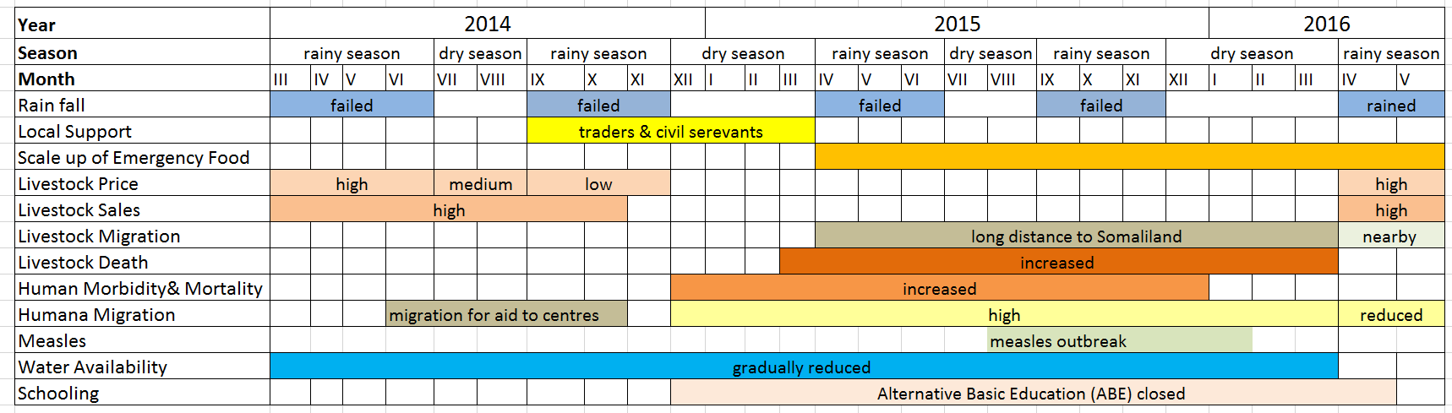

The patterns of wealth and of loss are very different in pastoral and crop farming economies. As was discussed above, the first poor short rain in early 2014 did not create a crisis in most kebeles in Sitti. Difficulties grew steadily greater during the dry period after the second rain failure (in late 2014 and early 2015). Livestock mortality peaked around Feb-March 2015, and this was also the period of measles outbreaks causing human mortality, presumably because of vulnerability caused by widespread malnutrition (see figure 7 above). However, in the same way, the end of the drought in 2016 has not brought an end to crisis. Asset loss is huge. Even if we assume that livestock losses were greatly exaggerated from the survey and FGD reports of around 80-85%, a very conservative estimate of 50% herd loss means that the average non-urban household lost around $3,750 worth of assets and is now suffering a loss of income from possible animal sales and milk of around $90 per month (see Table 1). Interviewing over the previous two years has shown that this is roughly the income needed for a household to cover its basic needs. This income loss will only slowly rise after one or two years, as animals become pregnant, give milk and then multiply, and full recovery will take longer.

By contrast, even though the drought in West Hararghe was not quite as severe (and over half of farmers managing to harvest some small yields throughout 2015), people suffered much more quickly after the failure of the first rain. Livelihoods are precarious in different ways in West Hararghe. The area is chronically poor, with the population only kept alive and in situ by annual distributions of aid (PSNP and JEOP), and people had few other possibilities to cope. Unlike Sitti, which is relatively asset wealthy with strong economic ties to the outside (‘bridging social capital’), people have few assets to sell beyond livestock and few possibilities to migrate. Although the dependency on aid (and the community sharing of aid) for survival may have been similar, in other respects the crisis was very different. There was much less loss of assets – people had few assets to lose, beyond their land. (Unlike livestock, land neither multiplies in good years nor dies in droughts.) Because animal holdings were small, people were better able to keep them alive during the drought, and in West Hararghe, unlike Sitti, the rains did not fail entirely, so that there was always some production of vegetation (see figs 5 and 7). The mortality calendar for West Hararghe is seen to dip each rainy season. Although animal holdings are smaller now, for most people they are down by less than half, and mainly because of sales, not death. Asset losses from mortality per household were only around 5% of those in Sitti, and income was largely restored with the first harvest after the return of rains.

Figure 8: Calendar of animal mortality in West Hararghe
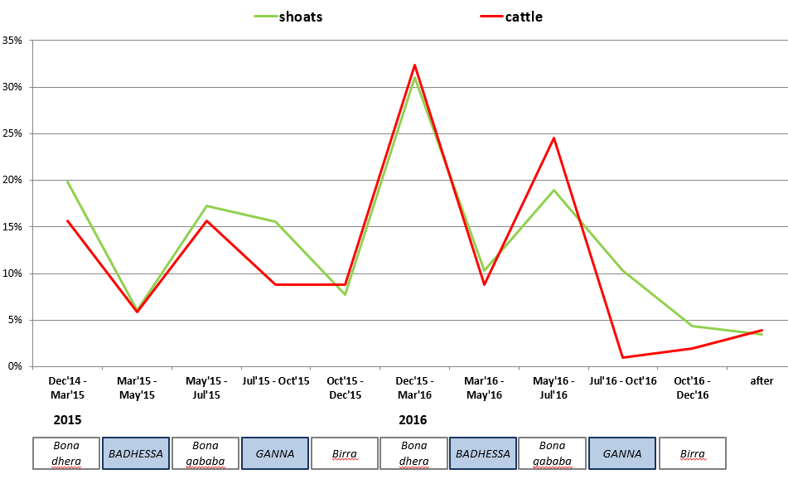
Both zones are chronically underdeveloped and marginalised, and significant numbers of people in both Zones regularly depend on aid for their survival because of unviable livelihoods. Both suffered from bad droughts, but the impact in Sitti was more clearly on of a long, acute shock, whereas the picture in West Hararghe can perhaps be understood better as the intensification of chronic poverty. In 2015, their aid dependence was much greater in degree, but less different in kind than the dependence in Siti. Although the aid sector tends to use poor and vulnerable interchangeably, household asset wealth is higher in Sitti than in West Hararghe, even though their livelihoods are more exposed to acute shocks. It is no surprise, then, that so much of the thinking around earlier response to protect assets comes from pastoral economies vulnerable to droughts.

Although this study is not a sufficient basis on which to draw final conclusions, these differences do seem to have implications for what would constitute timeliness and for the rationale behind early response. In an acute shock such as experienced in Sitti, there are opportunities to prevent additional impoverishment by taking extraordinary measures to support livelihoods. That this was not achieved in 2014-16 is due to a combination of four factors: the small scale of ad hoc interventions; the relative lateness of most of the livelihood protection interventions (i.e. in 2015, not in 2014); because an effective strategy would require major investment in planning and preparedness before the crisis, which has never been put in place on the level required; and, most importantly in this specific instance, because the extreme length of the drought (the most serious in thirty years) meant that even if interventions had been carried out in 2014 and at greater scale, they would have struggled to have succeeded in improving outcomes by very much.

In West Hararghe, on the other hand, in a situation of perennial poverty and/or dependence, and where there were no obvious windows of opportunity for preventing suffering or asset loss, the idea of being early or late is less critical. The main theoretical argument for early response may be limited to the prevention of suffering, or the lower costs involved, e.g. through addressing acute malnutrition before it becomes severe. This is beyond the scope of this paper, since it requires evidence on the links between food distributions and the prevalence of moderate acute malnutrition (MAM) and between treatment of MAM and the prevalence of severe acute malnutrition (SAM), both of which are more problematic to establish than intuition would suggest.

Conclusions

- Aid was largely late. In both West Hararghe and Sitti Zone, where the crisis started a year before the El Niño drought, emergency relief aid was only geared up on the ground months after most people were already in crisis. Although there was very little that could be called early aid, though, aid was largely in time to prevent mass mortality in both Sitti and West Hararghe. There were nevertheless some avoidable deaths from malnutrition and resulting disease in both Zones.
- There is no evidence that earlier aid for livelihood protection succeeded in preventing asset losses in the 2014-16 drought in Sitti or the 2015-2016 drought in West Hararghe.
- The exceptional scale of the drought in Sitti probably made it impossible to expect that losses could have been avoided, given the scale of resources available to humanitarian aid.
- The rationale for using aid for asset protection during a drought is clearer in an asset-based pastoral economy than in the arable economy of West Hararghe. On average, households have probably lost over $3,750 worth of livestock, and their potential post-drought income is reduced by over $90/month (i.e. around four times the minimum wage for public employees).
- However, the scale of the problem means that a very clear strategy would be needed to have a chance of preventing asset loss. This would need to be on a scale many times higher than the current projectised aid interventions. It would need to be accompanied by a level of investment in planning and preparedness, the need for which has not yet been fully recognised.
- It is obviously not a priority for operational emergency agencies to tackle the difficulties which a research study had in finding coordinated information about the relief effort. Their primary and urgent responsibility in a crisis is saving lives, not documentation. However, responders themselves have a need for coordinated information. Current information management systems do not help agencies to provide the information from which everyone should benefit without an excessive administrative burden, nor does it help them to access information in a form that is useful for their decision making without an excessive cost of time and effort. This is not the responsibility of individual agencies but is a system responsibility.

- Early warning
Early response is only made possible by early warning. Early warning can be interpreted in two ways, which are not always clearly distinguished:

- Giving advance warning of an impending shock, before it arrives. This information can be useful both to the people who will be affected by the shock, so that they can take avoidance or mitigation measures, and also to those who will support people affected by the shock (government at different levels, aid agencies, etc.), so that they can plan, prepare and deliver early aid;
- Giving warning of the early signs of crisis, i.e. after the shock, so that mitigation measures can be taken to prevent more serious suffering. This can help ensure timely aid. This information is useful to those responsible for supporting the crisis-affected (since the affected population will be aware of their own situation).

Many crises can be predicted in advance; people who will be affected by a crisis usually have some room for manoeuvre in preparing for a drought, if they are informed enough time in advance. These statements are surely uncontroversial. Farmers can make choices about recurrent expenditure, about what they plant or their search for other income sources; pastoralists and livestock keepers in general have a different range of strategic decisions, e.g. relating to markets or migration. Ongoing forecasts are also critical for those who are supporting them. Advance warning of hunger enables agencies to be prepared, but beyond that, only if it is known how long a drought is likely to last, is it possible to know what strategies make sense (e.g. as illustrated in box 1).

Much of what are called early warning systems in Ethiopia are devoted to the second task (above), e.g. drawing attention to where harvests have failed or where malnutrition is beginning to rise, to guide targeting of relief, and in this, there were some successes. However, in the first task, above, letting people know what shocks are impending, the early warning for the 2015-16 El Niño was an enormous failure.

Although many losses were sustained by pastoralists before El Niño, over half of the animal mortality occurred from June 2015 onwards. A temperature rise of 0.5⁰C in sub-surface sea temperatures (SST) is commonly taken as the threshold for an El Niño event. Figure 9 shows that by April 2015, meteorological models were predicting an El Niño event (red dotted lines), even if not one as severe as actually occurred (black line). By May 2015, it was already clear that a serious El Niño event was likely, with all predictions well above the El Niño threshold. Although it was impossible to be certain in May 2015 either about the severity of the developing El Niño event or about the exact weather patterns that would be created in any given place, there was already enough information in the public domain to expect poor long rains in Sitti and West Hararghe in July-October 2015. Given what was known about the crisis already existing in Sitti, this was enough to know that a major disaster needed to be prepared for.
Figure 9: April 2015 El Nino forecast
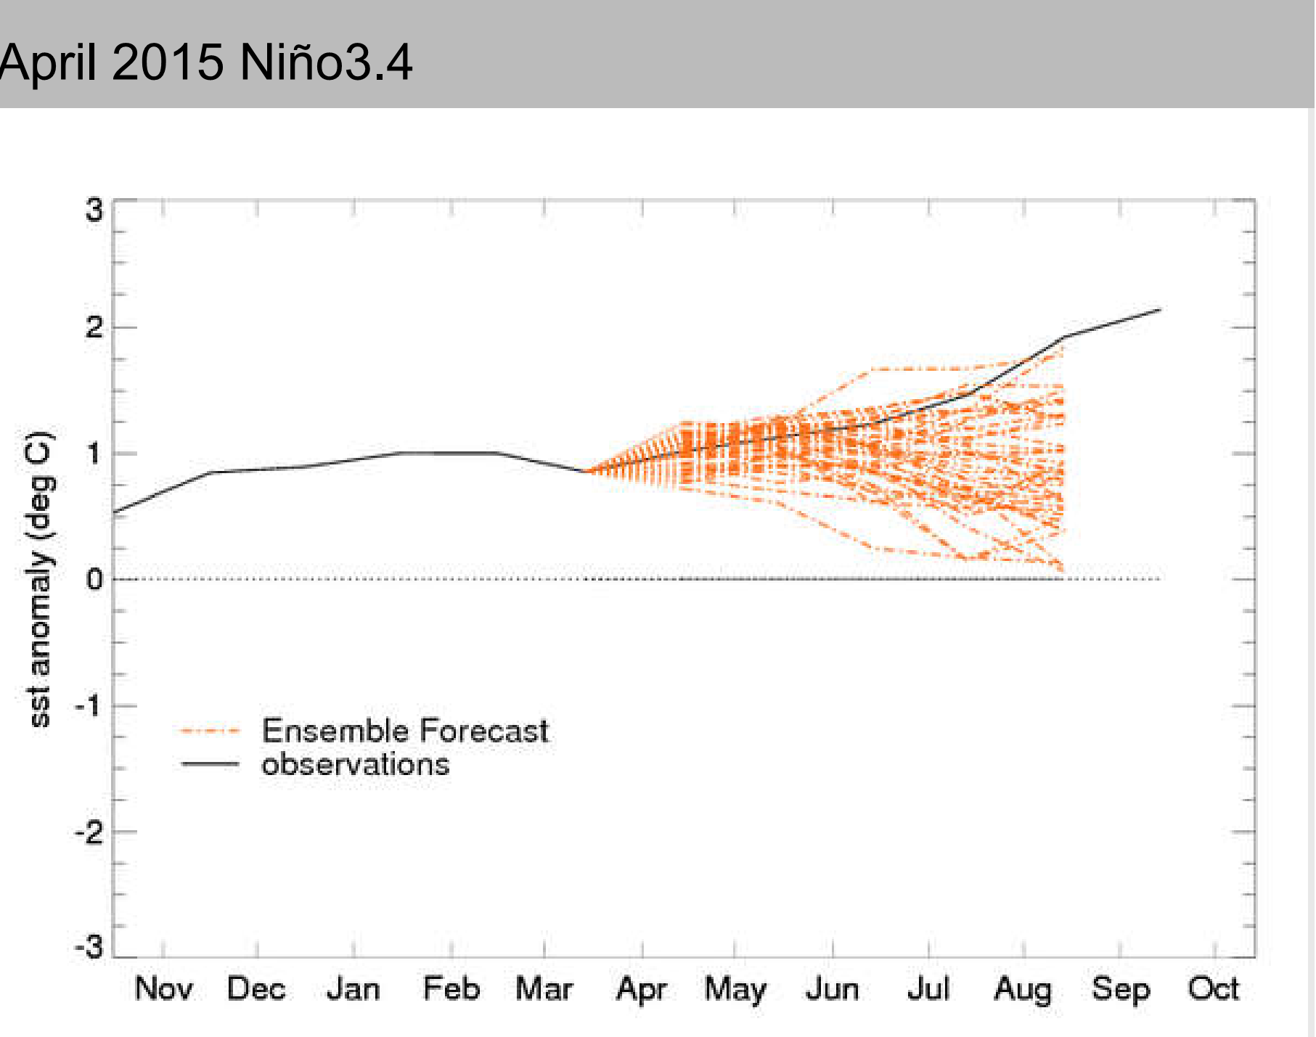
El Niño threshold

Figure 10: May 2015 El Nino forecast
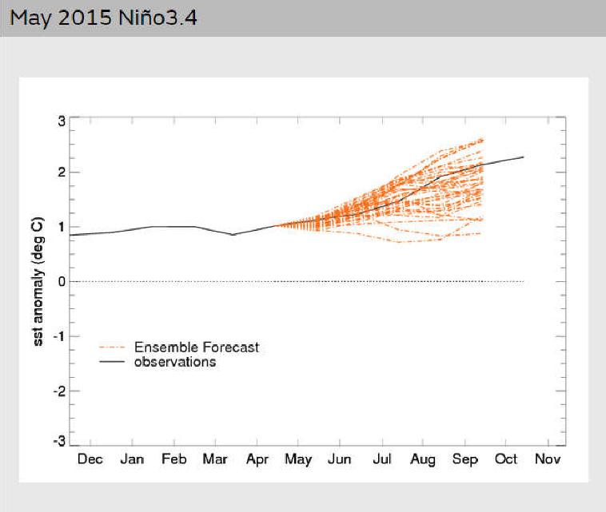
El Niño threshold
This information was not conveyed to those who would be affected, as evidenced by VE’s real time interviewing during 2015, the evidence heard during this study and from their behaviour. As a result, they struggled to keep alive as many of their animals as they could in the reasonable expectation that September would bring relief from the drought. Those who took their animals to Somaliland or who chose not to sell off their animals could have made better decisions had they know what was likely to come. They were badly let down by a failure to warn them of the poor forecasts, which prevented them from making informed decisions about a question of critical consequence for their lives. It is beyond the scope of this study to say why the best scientific information, publicly available, was not acted upon by agencies with a mandate to provide early warning and weather forecasting services.

Others too should have been informed. The prediction by April-May 2015 of failed long 2015 rains was in itself a prediction of a major humanitarian crisis, particularly where the 2014 rains had failed. Some agencies did their best to respond to, and to draw attention to, the increasingly severe situation, even at reputational risk to themselves, and they can be credited with helping to save many lives. However, this was a response to the symptoms of the drought that had already occurred. The Sitti Zone Multi-agency Rapid Assessment in May 2015 (UNOCHA 2015) calls attention to the critical condition already being faced in some parts of the zone, especially in Hadigala and Shinile, but makes no reference at all to any predictions or forecasts for the following rains. Had the assessment team been aware of the coming El Niño, they would have framed the looming crisis in very different terms. Projects planning can also be seen to have been undermined by ignorance of what was coming. For example, a restocking initiative was planned and undertaken in Sitti during the failed long 2015 rains with predictable results for the survival of the animals; the lack of impact of short-term fodder distributions in the middle of a long drought has been extensively discussed above.

Conclusions
- Investment has taken place over many years in early warning systems. These may be functioning well in identifying areas where the symptoms of crisis are already evident, but publicly available meteorological predictions were not integrated into the response to the looming crisis.
- Critical information, including weather forecasts, was not made available to those who would be affected by drought.
- The risk of El Niño drought was known with some confidence by April 2015, and in Sitti this meant the high probability of a very extreme crisis. Several decisions by agencies who were planning aid (Government, donor, UN and NGO) did not make sense in the light of that information. Either the agencies did not have the information or their planning procedures did not know how to use the information. This is a serious failing, but one that should be possible to rectify.

- The impact of longer term programmes on crises
For some time there has been a recognition that ad hoc short-term emergency interventions which are triggered by humanitarian indicators, are not capable of delivering aid in time to prevent suffering and impoverishment. Hope has been placed in the ability of longer term support to deliver on two fronts: to have sufficient built-in flexibility to respond to changing needs in real time (rather than several months later as emergency interventions often do); and to address the causes of vulnerability and thus to make people less dependent on emergency aid in the future. The extent to which long term programing succeeded in having a positive impact in each of these ways is assessed in turn.

Flexibility for earlier response

Village level research can reveal little about the extent to which programmes were flexible or to the degree which any flexibility had a positive impact. Aid recipients were not aware of which funds their aid was coming from or the length of any bureaucratic processes which delayed them. Different people in each kebele reported receiving aid of different kinds in different periods: aid received early was just as likely to have been aid intended from the previous year which had been very delayed. It had been hoped to compare the speed with which aid actually reached the ground in different kebeles according to which decision making and administrative processes were followed but this proved impossible because of the inadequacy of the management and coordination of information about aid programming and delivery.

Analysis has to rely instead on combining our understanding of the actual needs on the ground with the reports of the aid agencies about their attempts at flexibility. One of the most talked about mechanisms for building flexibility into longer term programming are so-called ‘crisis-modifiers’, a now bureaucratic arrangement which allows a recipient agency to use a certain percentage of an overall development budget for relief. The use of crisis modifiers in the recent drought was reviewed by Save the Children International, the findings of which lead to a certain caution in expectations regarding the ability of crisis modifiers to deliver either timeliness or a response which has the scale to be relevant.

Crisis modifiers are not yet fulfilling their potential to deliver timely relief assistance. Some donors were able to give approval for a change in the use of money in 2 weeks, whilst in other cases there was a delay of 6 months. Considering emergency funds can be made available in a matter of days for sudden-onset disasters, an average delay of three months to project approval does not appear game changing. Hopefully with time, donor and implementing agencies will learn how to work together to reduce such delays. AKLDP give an example that may offer lessons: an NGO which discussed with a donor what responses might be needed if rains failed (in January 2015, before the problem arose) was followed by action on the ground in May 2015, immediately after the failed rains.

A closer look leads to even more caution. Both Save the Children and Tufts have documented that crisis modifiers were predominantly requested between July 2015 and February 2016. However, in May 2015 knowledge was already available that a severe El Niño crisis was likely, and rains had failed since 2014 in Sitti – and even before that in West Hararghe. Crisis modifiers only began to be called for at the same time as the revised emergency appeal was launched (July 2015). This suggests that they were not seen as a possible mechanism for ‘early response’ in the sense of trying to mitigate a crisis before it developed. Indeed, crisis-modifiers were only activated after livestock mortality had already peaked in the study areas, and almost a year after aid-seeking displacement had been seen in Sitti Zone. In the case of Sitti, where the crisis began earlier than in some other parts of Ethiopia due to failure of 2014 rains, this built-in flexibility, designed to give early response, was still only triggered months after indicators of suffering were severe enough to cause the Somali business community of Dire Dawa to provide food aid for their own clan kin.

The date of requesting funds under the crisis modifier mechanism was not the date that funds were available to be used: it took up to a few months from that date for aid to reach recipients. It appears that there were three reasons for such delays. Crisis modifiers, although originally intended as a quick response mechanisms, have created their own bureaucracy and in some cases donors were not able to approve funds without significant delays. Two other reasons have been mentioned which have been identified before as problems in previous emergency responses in Ethiopia (and elsewhere). Donors found that operational agencies did not proactively engage with them before requesting money, to discuss possible responses and to help the donors to prepare. Finally, the time from receiving funds to delivering aid on the ground continues to be protracted.
Catley et al (ibid) draw attention to the fact that even the release of money in a timely way does not guarantee adequate assistance for those in need. There can be long delays between money being authorised and aid arriving on the ground (stressing the need to combine any introduction of flexibility mechanisms with proper contingency planning and preparedness); and the intervention itself must be of appropriate design and adequate quality. It was beyond the scope of this study to assess the actual design or performance of interventions financed through flexibility mechanisms, but the documentation by SCI and AKDPP raises some questions about some use of them. Some of the activities that they report were funded are not obviously in the category of rapid early response: training (health workers, WASH committees), project start-up costs and land rehabilitation would be expected to be covered from non-humanitarian funds. In-built flexibility mechanisms in long term programmes should help forge stronger links between short-term crisis response and a broader long-term strategy, but this was not always obvious. Distributing fodder for only two months when the forecasts were clearly for a much longer drought could be effective as part of a strategic response. In isolation, it risks having no impact at all if animals died anyway before the end of the drought. (The survey data showed no statistically significant impact of receiving fodder on the survival rates of livestock.) It should be stressed, though, that no specific investigation of these projects was carried out and so these are raised as questions about certain types of programming and not as criticisms of any specific intervention.

Flexibility mechanisms allow the use of a certain percentage of money to be diverted to respond to an emerging crisis. In many cases, the sums of money involved are quite small in relation to an emergency operation – often around $200,000. This must be seen in relation to an overall emergency appeal for 2016 of $1.4 billion. That does not mean that this flexibility is irrelevant, but unless the crisis is very localised, the funds from such sources will only play a major role in meeting very particular needs, e.g. for a short window before the main response is mobilised. In order to be effective in this way, collaboration and agreement in planning an overall response strategy is essential. Such collaboration or even coordination has not yet been achieved. In some of the larger programmes, the ability to spend funds earlier or to reallocate their use is more significant (e.g. multi-million dollar changes in EU support to PSNP and to UNICEF nutrition programming).

Investments in resilience

The design of this study had been to compare how households coped in villages which had received and those which had not received resilience investments of three different kinds: in asset building, in income generation and in water infrastructure. Although there have been a number of programmes in Sitti and West Hararghe Zones which could be called “resilience building” (whether labelled as development, livelihoods, etc.) it proved impossible over several months to find out from donors or implementing organisations the content of their projects, and what exactly had been done where or when. It therefore proved impossible to sample villages in order to make a comparison between beneficiary villages and control villages. The resulting sampling made it harder to learn about specific kinds of investments but did give a better unbiased picture of the overall contribution which such investment had made to the two Zones. The implications of the lack of any coherent picture of development investments should also be drawn at this point. If it is so difficult to obtain even the most basic information about what different agencies have done and are doing in a Zone, then those planning, implementing and funding such investments are obviously not doing so on the basis of a medium term strategy, or one that looks beyond immediate project beneficiaries. This only makes sense on two assumptions: that resilience depends entirely on factors at household or village (“community”) level; and that resilience is built by the simple addition of discrete units (e.g. assets owned, years of education received, access to specific services, etc.). These can each be individually bolted on to someone’s existing resilience, and are independent of each other. Neither of these assumptions are particularly tenable, either in theory or, as this study finds, in the real world.

Because of a lack of prior information about resilience investments that had been made, the study was not able to use quantitative analysis to assess their contribution to coping, because beneficiaries could not be included in the sampling methodology, either by sampling beneficiary households or even beneficiary villages. (We found no information at all on resilience investments or indeed other aid which went beyond kebele level to village level.) Specific questions could not be included in the survey, because agencies were not able to give us details on the projects they had run, but in any case, the numbers of beneficiaries were too small in a random sample, even if considering the village as a whole as beneficiaries.

Even had we done so, it became clear that there are methodological challenges of a different kind in attempting to measure the influence of resilience investments on coping. Various indicators of ‘struggling’, i.e. having difficulty in coping with the crisis, were elaborated and the survey measured these parameters. These included levels of debt, the extent of cutting back of meals (for adults and for children), asset sales above and beyond what would be normal, distress migration, loss of livestock, and subjective assessments of how they had coped, both in absolute terms and in relation to others in their communities. The lack of correlation between these variables is striking. This means that people who struggled in one way (eg cutting back on meals) were not more likely to have suffered in other ways (eg selling assets). The selective use of one variable that happens to correlate with an intervention is a dangerous tendency especially when it is used to support pro-project bias.

It even proved difficult to investigate the contribution of resilience investments through the qualitative research. The intention was to combine a quasi-goal-free and a TBIA enquiry. However, in order to get the details needed for the TBIA approach, it is important to find individuals who had been engaged with any interventions. These were so few that it was almost impossible to find them. Instead, we heard the standard anecdotal success stories (“X received a loan and has now built a house with corrugated iron roof”, or “..and now owns 10 goats”, with no explanation of the constraints they had previously faced or how typical their stories are.)

In goal free interviewing, there was little mention of resilience investments, except in water. The reason was obvious. In both Sitti and West Hararghe Zones, resilience investments played almost no role in helping people to cope with crisis, because the scale of those investments has been largely insignificant. The vast majority of people had simply not received any investments. For the most part, even when projects were known about, their scale was too small to be significant: a few individuals given vocational training, a dozen who were members of a savings group.

Where investments had been made, the appropriateness of the intervention design was mixed. There were some predictable reasons why some vocational training had impact, e.g. people who were trained as bakers who were not working, because there was no power supply for the ovens they were trained to use, or a mill which failed for the same reason. The provision of hybrid hens in West Hararghe resulted, predictably enough, in the death of most of the poultry, because neither vaccinations nor technical support for production were reliable. In some cases, the timing was simply inexplicable (e.g. the restocking programme in the middle of the drought in 2015).
Two particular intervention types have been widely used: savings and credit associations (particularly in West Hararghe) and water projects (in both Zones). As mentioned, several anecdotal success stories were heard about VSLA, but in any one village, these were only told of two or three individuals. VSLA have reached reasonable coverage – 7% of the West Hararghe survey sample reported using them – though we have no information on prior borrowing habits. The amounts borrowed are no higher in villages where VSLA use is high. Although some informants spoke of loans of up to $300, only a handful of survey respondents normally took loans over $100. Borrowing is thus much less prevalent and at lower values than in Sitti, even among those who would be categorised as among the ‘very poor’. Borrowing even from VSLA appears to have motivated more by consumption smoothing rather than for investment. However, VSLA did not play a major role in providing extra credit to cope with the drought crisis. Only 4% of households reported using VSLA for any extra borrowing during this period.

It is clear from the FGD that VSLA are largely only used to fund consumption, because the opportunities for profitable investment are so few. A few people had invested in livestock production, though almost everyone (87%) owned some livestock anyway. The main profitable investment was in the drug business, either in khat production or trading.
There has been some degree of investment in water in both Sitti and West Hararghe. In many cases this provided significant benefits for people, either in saving several hours of their time in collecting water, in improving the quality of their water or because it was the only water available. One of the reasons that people gave for migrating when they did was the lack of any water in their home villages. Even though investment may (correctly) be deemed resilience building, this does not mean that it is strategically linked to preventing or mitigating crisis needs. For example, it is noteworthy that the targeting of interventions of the One WASH programme excluded all the Districts which had been identified as having priority needs (the Hotspot-1 districts) both prior to, and even during, the drought. The programme had its own targeting rationale. It is impossible, though, to expect that investment in resilience building will have an impact either on the coping of people most in need during crises, or on the strains placed on humanitarian aid by crises, if investment programmes do not feel obliged to target at least some of the districts which are most likely to have acute needs in times of crisis.

Irrigation in particular is seen by many as the solution to the poverty that comes from a reliance on rain-fed farming in semi-arid areas. Villagers in West Hararghe frequently wanted to be given pumps to irrigate their khat fields, having seen the economic success of many of those who had these advantages.

Stories of success were evident and they are important. Irrigation has a critical role to play in making rain-fed agriculture more resilient. However, success stories need to be balanced against two cautionary factors. First, not all water systems work well. Too many have failed very quickly, usually because of maintenance issues, and several schemes have failed to reach their intended targets of beneficiaries, either because they were technically unable to deliver enough water to so many fields or because of implementation problems.

Even a working irrigation system does not guarantee livelihood impacts. In Sitti, though not (yet?) in the middle and higher altitude districts of West Hararghe, invasion by prosopis of irrigated plots has reduced the irrigated areas actually cultivated hugely. Most people (85%) reported problems with prosopis invasion and the area made inaccessible ranged from ‘almost half’ to ‘almost all’ for more than half of all respondents (58%), rendering huge investments in irrigation in many places largely worthless.

There are worrying stories in Hadigala District that the water table is already falling following the development of many artesian wells for irrigation, largely for resettlement. Pastoralists linked this development with the drying up for the first time of previously constant underground water sources, which had served as a last-resort water source in droughts. This was given as a reason why they had to migrate to Somaliland – where they lost most of their herds. This study could obviously not investigate that link, but it is plausible that overconsumption may be drawing down the water table. We were not able to find a technical (hydrological) analysis of the aquifer which was guiding its development and exploitation: it is certainly to be hoped that such an analysis has been adequately carried out and is indeed guiding development investment. As discussed above regarding the difficulty in strategic planning when project information and analysis is not widely available, if these studies are not easily available, the danger of uncoordinated and thus unsustainable development is unreasonably high. In Birder, Hadigala District, these same wells were blamed for infecting cattle with intestinal worms, which cause diarrhoea, swollen throat and eventually death. Deaths were reported to be running at two a week and this was said to be as bad equivalent or worse than the effect of the drought”. (Obviously, this cattle disease could not be independently examined by the Valid Evaluations study team.)

The second caution is that even when water systems generally work well, there may be no increase in resilience to droughts. Several water systems, both for domestic and agricultural use, failed in the drought, either because of a lack of water or because pumps could not work. This was variously due to shortages of fuel and also, reportedly, where electric pumps had been installed because of a failure of the electricity supply – which is generated through hydro-electric generating stations whose output falls in droughts. Even when the irrigation system itself worked, the only surviving vegetation in the area acted as a magnet for pests and wild animals.

Irrigation has brought substantial economic benefits to some, but it did not provide the general resilience to drought that may have been hoped. In Sitti, only a third of those with irrigated land were able to water their crops as normal even in 2015, and by the second rains in 2015, only 13% of those farmers – that is just 1.5% of households – reported having a reasonable harvest from irrigated agriculture. In West Hararghe, the situation was similar. Fewer households enjoy any irrigation (only 11%), and more than half of those had a poor harvest or no harvest at all from irrigated land in 2015. Only 13 households from the sample of 480 (2.5%) reported a reasonable irrigated harvest throughout 2015. These figures do not, of course, form an argument against investment in irrigation: but they do suggest that in the medium term, the impact of irrigation in supporting resilience to drought will be for limited populations and, even for these households, with a limited role.

The analysis of how wealth group status affected coping (see above) is also relevant to this discussion. One of the dominant paradigms of resilience is based on household asset ownership. Differences in productive assets are also the way in which wealth groups have usually been distinguished. However, the findings from this study (of just 2 Zones in one drought) suggest that the household asset dimension is far from being the sole determinant of resilience in drought. If these findings prove to be more generally applicable, then current household models may critically undervalue the important role played by the local economy as a whole, and the resilience of meso-level economic activity, in shaping economic resilience to droughts and other crises.

Conclusions:

There were positive instances where mechanisms for using longer term interventions to respond to developing crises were quicker and earlier than the majority of humanitarian aid. However:

- Some crisis modifiers and other flexibility instruments performed quickly, others didn’t. The name or type of funding mechanisms is in itself no guarantee of speed. There were even stark differences in how the same implementing agency used flexibility mechanisms from the same programme in different parts of the country.
- Quicker aid does not necessarily mean early aid, if the triggers for activating the processes for requesting money are set too late. Changing the bureaucratic processes by which money is released can be an important step, but is not a solution on its own. A much more fundamental change in the triggers for decision making is also needed.
- Given the limited scale of resources likely to be available through flexibility mechanisms, it is unlikely that they will ever be a significant part of a response to anything more than a very localised crisis or to a short window before a main relief operation arrives. It may prove more important to put more effort into speeding up the processes for this response rather than expecting the longer-term interventions to take care of needs.

On the relevance of resilience investments as way of helping people to cope and to avert excessive losses:
- It is not possible to detect any impacts of resilience investments on the success of coping or on losses sustained by households during the 2014-6 crisis in West Hararghe or Sitti. This is only partly due to methodological difficulties with impact assessment, but it does not imply that investment in resilience is irrelevant or inappropriate.
- The scale on which investments have been undertaken is far too small to have made any noticeable difference except on a small number of individual households.
- Even irrigation has provided a benefit for only a very small number of households.
- Resilience/development investments do not appear to be guided by a clear, coordinated strategy. This is worrying. It is only mitigated by the fact that such investments are in any case marginal.
- The stories of irrigation systems that dried up in a drought, machines (pumps, mills, ovens) that failed when the hydro-electric supply failed in the drought, and even irrigated fields that yielded nothing in the drought because they proved a magnet to pests and wild animals all point to a general lesson. Too often income diversification is automatically seen as increasing resilience. However, if the new income source is as vulnerable to the same shocks as previously existing livelihoods, then there may be gains in good years, but no increase in resilience to shocks.

- Summary of conclusions

This study set out to answer questions in three areas:

- Early response and the degree to which delivering aid early helped prevent loss of productive assets, indebtedness and other distress strategies;
- How far investments in building people’s resilience helped the to cope better with the crisis;
- Whether the flexibility of longer term programmes was effective ensuring the delivery of earlier assistance.

It is clear from the discussion above that the study found clear-cut answers to any of the questions to be elusive. Indeed, one of the strongest conclusions that comes through all of the findings is how much caution we need to exercise to control our need for simple answers, and the ease with which simple yet apparently plausible tools can be created. It should not be surprising that the VE study found that whatever could reliably be said about the crisis in any one village, the opposite could be true in a neighbouring village. It should be worrying though if this variation is regarded as something to get beyond ( as if ‘to find out the true picture’), rather than as what needs to be understood.
Even if the research did not lead to any clear-cut answers about early response, resilience building or flexibility in longer-term programing, the findings do allow for much to be said on these topics.
First, it is appropriate to begin this section by repeating that this study is not an evaluation of the 2014-16 aid response. The enormous efforts of Governments, organisations and individuals to mitigate human suffering without doubt resulted in thousands of lives being saved. This report must acknowledge this before making any critique of a particular aspect of that response, the role of aid in protecting livelihoods.
Second, it must be acknowledged that, particularly in Sitti, the crisis was one of the most severe in decades. Expecting aid to protect livelihoods for such a long drought is a difficult pass mark for them to meet. The lack of impact that the VE study team found does not invalidate the approach; it is possible that there would have been more impact in less severe crises.

It is easy to frame the discussion about aid to Sitti and West Hararghe in 2014-16 as about an emergency response to a natural disaster. The 2014-16 drought was, clearly, a particularly severe one, which has drawn comparisons with the drought of 1984. However, a focus solely on rain failure and the humanitarian effort to save lives risks missing an equally important dimension of the crisis suffered in both Sitti and West Hararghe. Crises, it has been argued, are created by a combination of shocks and underlying vulnerability, and the less proximate causes of crisis need as much attention as the rain failure. These underlying causes in Sitti and West Hararghe have similar roots, even if they present slightly different faces. In both Sitti and West Hararghe, chronic underdevelopment has created a population with unviable livelihoods, and extreme vulnerability to the kinds of shocks that they continually face.

There was little genuinely early aid to research in West Hararghe or Sitti, particularly aid that was intended to help prevent losses. Even the relatively more timely assistance in both zones only arrived months after the crisis had taken hold. Sadly, the picture has not changed enough in the last decade, when Levine et al (2011) found that aid is late because no one had really tried to work out what ‘on time’ would be. There is still too little appreciation of the role of predictions in disaster risk management and crisis management. Early warning is understood as picking up worrying humanitarian indictors (ie after a shock) rather than providing all those who need it (including those who will be affected) with the information about impending shocks. This is particularly striking regarding the El Niño part of the drought (2015-16), given the global attention which this phenomenon receives from meteorologists.

Various mechanisms built in to longer term programmes to enable quicker response were more widely used in this crisis than has been the case, and their use showed some promise. As with so much in the aid sector, their greatest failing may be the fact that so much potential is claimed for them. They will never be more than a very limited part of a response, even of early response, and their three basic limitations need to be recognised: they have very limited funds available in relation to the humanitarian need; they are not immune to bureaucratic delay; and they are part of the same aid system that is not yet committed to early response (incorporating prediction into planning, identifying what on time would be, ensuring windows of opportunity are met, returning money that could not be spent within the window of opportunity, etc.)

In pastoral areas, the increasingly favoured livestock interventions were used by several agencies, but on an ad hoc basis. Without a sustained engagement, and without any clear strategic plan or rationale behind the interventions, it is not surprising that impact cannot be found after one of the most severe droughts in decades. Nothing can be concluded from this about the potential usefulness of these intervention types as whole – though unless the response is explicitly designed in relation to the size of what needs to be seen through, it would be unlikely that agency expectations could be met. Although relatively innovative in many ways, these interventions have nevertheless followed a standard humanitarian model – transfers (fodder, vet vouchers, etc) to vulnerable households. The economic catastrophe caused by drought – at least $275m, and possibly much more, of lost livestock in Sitti zone alone – is huge, and it is right to give it attention. It is likely, though, that very different kinds of strategies will need to replace the current models to be able to tackle the scale of the problem. That discussion was beyond the scope of this report but will be discussed in the future Ethiopia country report for the MYHF thematic evaluation.

It was difficult to find the impact of resilience building investments because so little investment has actually taken place. There are two problems to overcome.

- A handful of short term aid projects cannot be a substitute for real investment. To put this in context: on a per capita basis, to compare with the loans and grants (including from the Marshall Plan) which the UK, a country with an advanced, if damaged infrastructure, received from the USA after the Second World War, Sitti Zone would need an investment of around $800m over three years. This is order of magnitude more than the investment in resilience aid projects.
- Ad hoc projects do not aggregate into a plan. The difficulties which the study team found in accessing information about the resilience investments made the study more difficult, but its real importance is as the symptom of a deeper problem. There is no clear, guiding strategy behind the spending. This would need a realistic analysis of what a resilient Sitti and a resilient West Hararghe would look like; a realistic path to achieving this; and a realistic costing of implementing that path.

Some may argue that this report is too critical of humanitarian agencies. It is unreasonable, it could be argued, to expect humanitarian agencies to take responsibility for the lack of economic development in places like Sitti and West Hararghe. Their priority in a crisis must be to respond to urgent needs; the resources are not available to create grand strategies and plans in order to protect people’s livelihoods. It would be equally unfair to expect humanitarian agencies to respond at this scale when there is no crisis, as their attention will inevitably – and rightly – be moved to other places in the world where crises are in progress. If livelihoods have not been sustainable in West Hararghe for many years, why should we expect aid projects to transform the zone in 2-3 years into a place where humanitarian aid will no longer be needed?

The question is a fair one, though it stems from questions about the expectations of aid which were not raised by the VE study team, but which have become common within the aid community itself, and which were therefore raised as research questions by DFID and USAID. The question, though, raises much broader questions about the roles and expectations of aid, and the nature of resilience to crises. These are questions to which this study raises some contributions, but which will be examined in more detail by the VE study team in its MYHF evaluation final reports in the near future.

Bibliography
AKLDP 2016 El Niño In Ethiopia: Impacts Of Drought On Young Rural Women In Eastern Amhara National Regional State. Field Notes. Addis Ababa; AKLDP/Tufts University.
Burns J and S Bogale 2011 Impact Assessment of Microfinance Honey and Crop Value Chain Interventions Final Impact Assessment of the PSNP Plus in Doba Woreda. Tufts University.
Catley A and Alula Iyasu 2010 Moving Up or Moving Out? A Rapid Livelihoods and Conflict Analysis in Mieso-Mulu Woreda, Shinile Zone, Somali Region, Ethiopia. MA; Tufts University
Catley A, A Kallis and Dawit Abebe, 2016. El Niño in Ethiopia, 2015 – 2016. A real-time review of impacts and responses. Addis Ababa; AKLDP/Tufts University.
Clarke D and S Dercon. 2016 Dull Disasters: how planning ahead will make a difference. Oxford University press
FEG 2008 Livelihood Profile Oromia Region, Ethiopia Charcher/Gololcha Coffee, Chat & Maize (CGC) LZ April Government of Ethiopia
FEG 2008 Livelihood Profile Oromia Region, Ethiopia Sorghum, Maize and Chat (SMC) Livelihood Zone
FEG (forthcoming) Ethiopia Livelihood Baseline Profile: Somali Region. Shinile Pastoral (SHP) Livelihood Zone.
FEG (forthcoming) Ethiopia Livelihood Baseline Profile: Somali Region Shinile Agropastoral (SAP) Livelihood Zone.
Food Security and Nutrition Working Group (FSNWG) 2017 East Africa Crossborder Trade Bulletin, January 2017 Volume 16. FEWSNET/FAO/WFP; Nairobi
Funnell, S. C., and Rogers, P. J. (2011). Purposeful Program Theory. San Francisco, CA: Jossey-Bass.
Levine, S. 2011. System Failure? Revisiting the problems of timely response to crises in the Horn of Africa. Humanitarian Practice Network Paper 71. London; ODI.
Niemistö N. 2011 THE RESILIENCE OF RURAL ETHIOPIAN LIVELIHOODS. A case study from Hararghe zone, Eastern Ethiopia. University of Jyväskylä.
Sagara B and D Hudner 2017 ENHANCING RESILIENCE TO SEVERE DROUGHT: WHAT WORKS? Evidence from Mercy Corps’ PRIME Program in the Somali region of Ethiopia. Mercy Corps
Save the Children 2002 Shinile Pastoral Livelihood Zone. HEA Baseline Study. Save the Children.
Save the Children 2001 Shinile Agro-Pastoral Livelihood Zone. HEA Baseline Study. Save the Children.
Save the Children 2016 Crisis Modifiers in the Drought Response: Ethiopia Country Office. Unpublished.
Smith L, T Frankenberger, B Langworthy, S Martin, T Spangler, S Nelson and J Downen 2015. Ethiopia Pastoralist Areas Resilience Improvement and Market Expansion (PRIME) Project Impact Evaluation Baseline Survey Report Volume 1: Main Report. USAID.
Smith L and T Frankenberger 2016 Resilience in Ethiopia PRIME: RMS Phase I Deep Dive. USAID.
Smith L and T Frankenberger 2017 Pastoralist Areas Resilience Improvement and Market Expansion (PRIME) Recurrent Monitoring Survey 2014-15 Deep Dive: Uncovering the Pathways to Resilience
Toulmin C 1986. Pastoral livestock losses and post-drought rehabilitation in Sub-saharan Africa: Policy options and issues. African Livestock Policy Analysis Network Paper No 8. Ethiopia; ILCA.
UNOCHA 2015 Sitti Zone Multi-agency Rapid Assessment in May 2015. UNOCHA
Scriven M 1991 Prose and Cons about Goal Free evaluation. American Journal of Evaluation. 1991. 12; 55.
WFP 2005 Emergency Food Security Assessment Handbook. First Edition. 2005. Rome; WFP
White H 2009 Theory Based Impact Evaluation: Principles And Practice. Working paper 3. New Delhi; International initiative for impact evaluation
World Bank 2016. Ethiopia public expenditure review.

Annexes
Annex 1: Correlation between parameters related to coping, stress and suffering (West Hararghe)
 | migration | distress asset sales | abnormal borrowing | reduction in meals | self-assessed coping | self-assessed, comparative coping | anticipated recovery time | sale of breeding animals | reduction in herd (as %)
Migration | 1 | -.060 | .064 | .032 | .027 | .016 | .007 | -.088 | .029
distress asset sales | -.060 | 1 | -.091 | -.014 | -.027 | .050 | .169 | -.011 | .025
abnormal borrowing | .064 | -.091 | 1 | .120 | -.036 | .072 | -.121 | -.023 | .026
reduction in meals | .032 | -.014 | .120 | 1 | -.108 | -.003 | -.130 | -.088 | .030
self-assessed coping | .027 | -.027 | -.036 | -.108 | 1 | .434 | .130 | -.040 | -.006
self-assessed, comparative coping | .016 | .050 | .072 | -.003 | .434 | 1 | .001 | -.049 | .020
anticipated recovery time | .007 | .169 | -.121 | -.130 | .130 | .001 | 1 | .033 | -.046
sale of breeding animals | -.088 | -.011 | -.023 | -.088 | -.040 | -.049 | .033 | 1 | -.065
reduction in herd (as %) | .029 | .025 | .026 | .030 | -.006 | .020 | -.046 | -.065 | 1

Unshaded numbers mean that there is no statistically significant correlation. Yellow shading indicates weak correlation. There were no medium or strong correlations. Note, though, that some correlations are inverse, e.g. those with greater debt were less likely to have reduced meals. Such competing indicators may offer clues to the different choices and alternative strategies that people faced, but they complicate the creation of a composite score still further
Annex 2: Cluster analysis
Sitti Zone |  | cluster 1 | cluster 2 | cluster 3
 | n = | 108 | 176 | 183
Migration | yes | 11% | 76% | 11%
migration for relief aid | yes | 3% | 19% | 2%
asset sales | yes | 2% | 3% | 2%
extra borrowing | yes | 19% | 65% | 9%
current debt (excess) | mean (USD) | $26 | $95 | $11
repayment period | no debt | 81% | 35% | 87%
 | ≤ 1 year | 9% | 23% | 7%
 | 2 years | 6% | 15% | 5%
 | ≥ 3 years | 5% | 18% | 1%
meal reduction | Yes | 2% | 97% | 100%
adult meals/day | Mean | 3.0 | 1.8 | 1.6
children meals/day | Mean | 3.0 | 2.3 | 2.3
self-assessment of coping | quite well | 34% | 13% | 6%
 | Badly | 66% | 87% | 94%
self-assessment, comparative | better (much, a bit) | 33% | 11% | 16%
 | about the same | 50% | 65% | 37%
 | worse (much, a bit) | 17% | 24% | 47%
recovery period | Mean | 2.6 | 2.7 | 2.6
sale, breeding goats | Mean | 3.2 | 5.3 | 4.1
sale, breeding sheep | Mean | 2.3 | 4.9 | 3.3
sale, breeding cattle | Mean | 0.4 | 0.5 | 0.4
sale, breeding camels | Mean | 0.0 | 0.2 | 0.1

West Hararghe Zone |  | Cluster 1 | Cluster 2 | Cluster 3
 | n = | 93 | 201 | 186
Migration | Yes | 4% | 9% | 3%
Sale of assets | Yes |  | 4% | 1%
extra borrowing | Yes |  | 59%
current debt (excess) | Mean | 0 | 596 | 0
repayment time | No debt | 100% | 41% | 100%
 | 0-6 months |  | 27%
 | 6 months - 1 year |  | 24%
 | about 2 years or more |  | 8%
meal reduction | yes | 1% | 90% | 100%
adult meal/day | mean | 3.0 | 1.9 | 1.8
children meals/day | mean | 3.0 | 2.6 | 2.5
self-assessment of coping | quite well | 32% | 24% | 9%
 | badly | 68% | 76% | 91%
self-assessment coping (compared to others) | better (much, a bit) | 29% | 45% | 6%
 | about the same | 54% | 30% | 76%
 | worse (much, a bit) | 17% | 25% | 18%
predicted recovery time | mean | 2.5 | 3.5 | 2.9
sale breeding shoats | mean | 1.1 | 2.3 | 2.0
sale breeding cattle | mean | 0.5 | 0.7 | 0.6

Annex 3: Crisis calendars, Tulo and Anchar Districts, West Hararghe

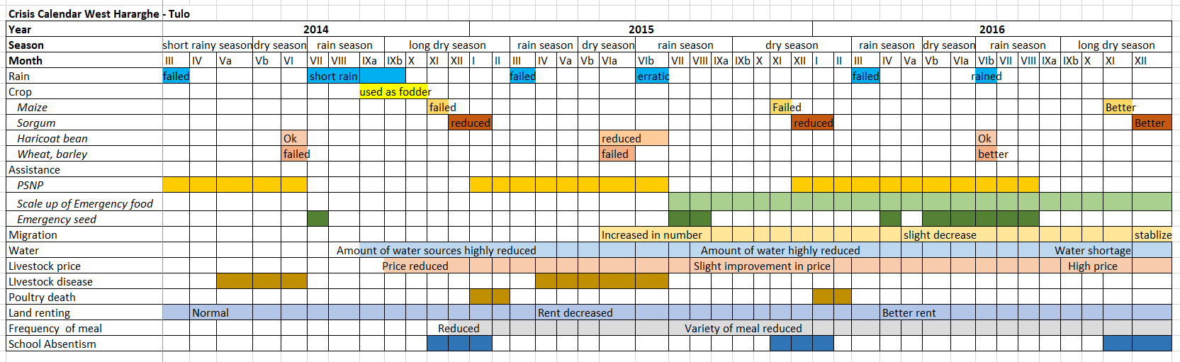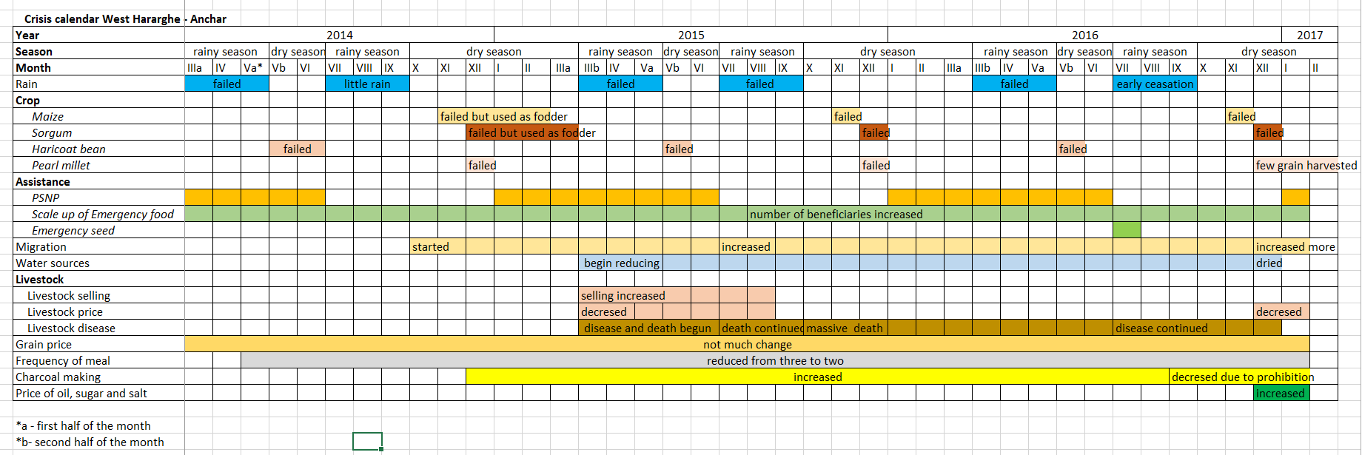
Annex 4: Definition of wealth groups

Wealth groups in Sitti Zone:
- very poor: people who own up to 5 TLUs (before crisis)
- poor: people who own more than 5 TLUs but less than 15 (before crisis)
- middle: people who own 15-30 TLUs (before crisis)
- better off: people who own more than 30 TLUs (before crisis) OR have a paid job

Wealth groups in West Hararghe:
- poor: people who own 1-2 timad of rainfed land IF they do not own more than 2 cattle (before crisis)
- middle: people who own 3-4 timad of rainfed land OR 3-4 cattle (before crisis) OR 1 timad of irrigated land
- better off: sum of number of cattle and timad of rainfed land must be at least ‘10’ OR 2+ timad of irrigated land OR have a paid job

Annex 6: Causal chains and interview guides for resilience interventions
Fodder production
Intervention: possibly distribution of ‘seeds’ (or cuttings, etc.); possibly technical advice. It is possible that intervention is mainly around growing fodder species for the first time. Possible also that it is about how to make better hay, how to cut grass, how to store, it.
Assuming it is about growing fodder species, then the causal chain is as follows.
Training given and seeds given ->
- Targeted beneficiaries have skills and material to plant fodder ->
- They plant fodder ->
- Fodder grows ->
- They harvest fodder ->
- They earn money from fodder OR 5b). their livestock have more fodder to eat/time . saved in feeding animals ->
- Livestock have lower mortality/higher reproduction, or are in better condition or give more milk ->
- Their livestock gives them more income (more animals to sell, or better price for each animal) and/or more milk to drink ->
- They spend money to benefit household ->
- Household is more resilient.

- Did the training work? Do they have the skills? Did the planting material survive, reach them on time? Mainly implementation issues, so we don’t need to probe too much, just to check quickly.
- To plant, what did they need? - Land? Water? Time/money for labour? (How much capital did they need in total?) Did they have all these? Does everyone have these – i.e. how far is it possible for the production of fodder to be copied by others? How do they get the land – what was the land being used for before? By whom? (Are there any losers from the project?)
- Did the technology work? Are they still doing it? What happened during the drought – did the fodder grow? How – if irrigation, was this new?
- How much did they harvest? How often, when? In normal year? In drought?
- Good calculations needed, including:
  - What is the market like? How big, which seasons? In a good year, in a drought year?
  - How much money in total from the sales? (Per week? For how many weeks? Or total per season? How many seasons a year?)
  - Total costs of production – labour (planting, weeding, harvesting, etc.), water/fuel, seeds, fertiliser (unlikely?)
  - Costs of sale – transport to market, taxes, etc.
  - ‘opportunity cost’?. If they were not growing fodder what would they have done – with their time, with the money they used, with the land and (if irrigated) with the water? Would they have planted anything (did they used to plant before?) What? How much money would this earn? How much more money do they make with fodder than with alternatives? A good check– are they continuing to grow it 2 or 3 (or more) years later? Are other people copying them, and starting to grow it too? If not, why not?
5b) Quantification needed. How much fodder? How many animals can eat it for how long? Important to consider – in which season did the fodder help – a time when there is little else or when there are more alternatives? If they didn’t have the fodder, what would the animals have eaten? If they had to take animals far, did it save them time? What advantage was this (e.g. how did they spend that time?)

- This needs quantifying – how many animals were eating? What was mortality – what do they think it would have been without the fodder? For both normal year and drought (assuming they also grew in drought year). If improvement in condition – how big a difference? For milk –quantify total milk yield (e.g. litres per day) in different seasons and in drought with/without fodder
- Did they sell animals? How many, at what price and what price do they think they would have sold without the fodder? If fewer died, how much bigger is their herd? How many more females do they estimate than would have been without fodder?
- Use of the money? What difference did it make to them during the drought (again, assuming fodder grew in the drought)
- What is this ‘point of resilience’? How big a contribution can fodder production make? E.g. what scale of fodder would they need to grow to be resilient? Does it help them in drought years or only normal years? How far is it possible to achieve wider resilience in this way – is intervention replicable? How many people could copy them – e.g. land and water availability?
Water provision (causal chain only)
Project installs some ‘structure’ (repair or new borehole/pump, protected spring, earth dam, etc.) ->
- Water structure (well, dam, etc.) is still functioning
- Structure is providing water
- People can access the water
- People use the water
- People a) have more water AND/OR b) save time in collecting water
Then either :
6a) people use water for income generation (selling water, growing veg, tea shops, etc.) or people use water for livestock (note – possible health benefits, but we won’t be able to assess this)
7a) livestock are in better condition/lower mortality/more milk production
8a) more income from IGA or from livestock
OR
6b) people use the time saved for economic activities and/or children use time saved to go to school
7b) people have more income (or: more children get education)

Leading to: households are more resilient

The use of the term ‘IDP’ to describe those who move to centres for distributing relief food and/or water is highly questionable. There is a great deal of politics, of various kinds, in the various arguments for or against policies which favour or encourage the creation of such centres and population concentrations. These populations should not be confused with those longer-standing populations displaced by conflict in some pastoral areas, for whom the term IDP is appropriate.
The calendar of animal mortality was elaborated by asking survey respondents when their animals died. The numbers of households reporting livestock dying in each period is used as a useful, but imperfect, proxy for the calendar of prevalence of livestock mortality (though it does not consider how many animals in each household died in each period).
When coping strategies are no longer enough, people may have to survive crises by using strategies with longer-term negative consequences, because they “undermine future means of livelihood, dignity or nutritional status, increase long-term vulnerability, or are illegal or not socially acceptable” (WFP 2005, p39). (Coping strategies, on the other hand, are ways of getting through a crisis without longer term harm.)
The kebele is the lowest administrative unit in Ethiopia, usually comprised of several villages often several kilometers apart.
See the profiles of Sorghum-Maize-Chat (SMC) and Charcher/Gololcha Coffee, Chat & Maize (CGC) livelihood zones at www.heawebsite.org
The leaves of the plant Catha edulis are chewed legally in Ethiopia, but it is an illegal drug in most of the EU and in the USA. Its two amphetamine-like active ingredients are cathinone and cathine, the former classified as a schedule 1 drug in the USA. Addiction to, or psychological dependency on, khat is widespread across the Horn of Africa and in Yemen.
Truly goal free evaluation is fully blinded, in that even the researchers do not know what were the specific objectives of what is being evaluated. See Scriven 1991.
For more details on theory based impact assessment or programme theory based evaluation, see White, 2009 and Funnell and Rogers 2011. An example of one of the causal chains used by this study is included in annex 6.
The theoretical, methodological challenges presented by this will be discussed in greater detail in a later paper.
The earlier rainy season is respectively called diraa, guu, badhessa and belg in Sitti Zone, Somali region generally, West Hararghe and nationally in Ethiopia, and in much of the country these are the shorter rains. The later, and often longer, rains are respectively called karaan, deyr, ganna or kremt. For simplicity, this study will refer to the diraa and badhesssa seasons as the short rains, and the karaan and ganna seasons as the long rains, though this does not imply any relative duration of actual rainfall in the relevant years.
Draft HEA baseline, (FEG forthcoming).
In Gurgur, Gabi, Gaad, Cayliso, Biyogaraa, Baraq, Harwo and Xadhikalay, only a quarter or less of the population reported that the crisis had already begun in 2014 (source: VE survey). In Birdheer, Bisle Dhidinle, Fadhato, Hadigala, Meeto and Geedwyn, over two thirds of the population reported that they had been in crisis in 2014, and except in the last kebele, more than three-quarters. (source: VE survey. Differences are statistically significant.)
The VE study team was told of several people killed in conflict as they attempted to migrate to Oromia with their livestock.
Irregular rains can be almost as bad as no rain. The long rains began in 2015, but there was then a long dry spell, followed by very heavy rain in September, which caused a lot of crop damage and very poor harvests. (source: VE interviewing from MYHF thematic evaluation.)
W Hararghe’s role in the khat trade is no more an indicator of its overall integration into a mainstream national economy than is the dependence of parts of Afghanistan on poppy production, remote parts of Pakistan on cannabis or inaccessible parts of Colombia on coca leaf evidence that they are broadly integrated into a global economy.
Unfortunately, it is not known what those numbers are. Deaths are not recorded as being due to malnutrition if there is some other more politically acceptable infection or proximate cause which can be given instead.
Survey respondents were separately asked when the crisis began and when it ended. Figures in the graphs are for those for whom the crisis had begun, but not yet ended.
HEA profiles present a typical description of the households in each wealth group rather than giving strict definitions with upper and lower limits. The criteria which were used in this study for categorising each household on the basis of survey data are described in Annex 4.
The profiles are in the process of being updated.
Prosopis juliflora, or mesquite, is a highly invasive thorny shrub introduced to the area by aid agencies, that is proving difficult to eradicate. It not only occupies large areas of irrigated land, but has created huge impenetrable barriers to accessing pasture and watering points, provides refuge for wild predators and is poisonous if ingested in large quantities by livestock.
Based on projections from 2007 census
Total SRS budget was 5.2bn ETB (c. $280m @ $1=18.5 ETB) in 2012/3 (Ethiopia Public Expenditure Review, World Bank, 2016). This equates to $53 per capita at a State population of 5.3m, or $29m for the population of Sitti Zone.
In one sense, selling an animal for money should not be considered as a loss. However, excess sales represent the loss caused by the drought from both the increased need to buy food because of a drought and, in particular, because of the huge reduction in sale price of animals. Qualitative interviewing found that neither pastoralists nor agro-pastoralists had used an expectation of drought to sell extra animals before prices collapsed. These excess sales thus form part of the erosion of assets that was caused by the drought.
Assuming 56% herd depletion, but considering also the change in herd composition. Herders protect adult female animals as much as possible, and breeding animals make up a higher percentage of herds than before the drought– an increase from 57% of all the animals in an average herd to 69% for cattle, and from 53% to 65% for shoats. (Source: Valid Evaluation survey, 2016). Milk is usually consumed rather than sold, and was given an equivalent monetary value here of 50% of the reported pre-crisis market price in Sitti Zone, from Valid Evaluation interview data 2014-16.
From the study kebeles, schools closed in Bisle, Biyogaraaca, Cayiliso, Gaad and Harwo.
All percentages here refer to the proportion of households who had children in school before the drought. Households with no school age children or whose children had not been in school anyway have been excluded from the sample. 80% of households in West Hararghe but just 67% of households in Sitti and reported having children in school before the drought, though only 6% and 5% respectively reported having no children in the household. (This question did not refer to school-age children.).
Care must be taken, though, in assuming that the findings at village level are representative of the kebeles as a whole, since only one village was sampled in any kebele. We believe that there are differences between different villages in the same kebele, because, for example, villages in Sitti that were more peripheral from the kebele centre were more likely to report being in crisis by the end of 2014 than the central village in the kebele (55% compared to 40%). There were no such differences in West Hararghe.
See Levine et al 2011 for more detailed examples of crisis calendars, and a discussion on combining livelihood analysis with crisis calendar analysis to determine these windows of opportunity.
The potential for reformulating resilience strategies at a higher level, e.g. around a meso-level economy and taking a much wider view of the livestock production value chain, will be analysed further in VE’s summative report on MYHF and resilience in Ethiopia.
There were only 7 beneficiaries in West Hararghe, making comparisons impossible. Livestock losses were assessed using both absolute numbers of deaths and sales across species, and also at sales, mortality and the numbers remaining at the end of the drought the a percentage of the pre-crisis herd.
The tropical livestock unit is based on aggregating animal weight. 12.5 TLU corresponds to 12.5 camels, 18 head of cattle or 125 shoats.
The time taken for herds to recover will vary enormously, depending on species composition, weather conditions in the following years, economic and market conditions (which determine how many animals can be bought or need to be sold), animal health, etc. If there are no further shocks in the intervening period, it could take 10 years for a cattle herd to recover from 40% losses from internal herd multiplication (Toulmin 1986), though many livestock owners will try to shorten this period by using funds from other sources to invest in restocking.
It is sometimes useful to distinguish bonding social capital – people’s ties within their communities – with bridging social capital, ties which people have to those outside their communities or which exist between communities. This distinction helps to make it clearer why the Somali cultural system of clans matches so well with their need for a mobile economy, which both create and exploit high degrees of bridging social capital.
This analysis is related to livelihood protection. It is obviously quite different in considering what would count as a timely response to life-threatening problems such as measles or severe acute malnutrition.
This refers to livelihood support designed to mitigate a crisis in advance. It obviously does not mean that emergency relief, delivered after humanitarian indicators were severe, had no impact on helping households through the drought.
http://www.metoffice.gov.uk/research/climate/seasonal-to-decadal/gpc-outlooks/el-Niño -la-nina
Source: ibid
Save the Children 2016 and Catley et al 12016
This problem was identified in Levine (2011, p 7).
This problem, and how to address it, was analysed extensively in Levine (2011, pp 12-15).
The benefits of time saved are in a reduced workload and in having more time for domestic duties and child care. However, there was no evidence of any direct economic benefit from time saved, i.e. allowing time to be used for any food or income generation.
Where water for irrigation flows through a drilled hole from underground under its own pressure without the need for pumps.

